

Department of Agricultural and Environmental Sciences - Production, Landscape, Agro-energy

CONTRATTO DI RICERCA TRA SANPELLEGRINO S.P.A. E Università - DiSAA-GeSdiMont per l’applicazione del metodo Volumetric Water Benefit Accounting (VWBA) al caso dei versanti in gestione al Consorzio Forestale Alta Valtellina

Water-related
multi-hazard assessment for evaluating vWBA of water stewardship activities: the case of Valdisotto (Italy)

Principal investigators: Prof. Gian Battista Bischetti and Prof. Giorgio Vacchiano
Working group: Dr. Alessio Cislaghi, Dr. Michele Franzini, Dr. Gianfranco Gregorini, Prof. Paola Morando, Matteo Crippa, Eleonora Ippolito, Davide Romanelli

Summary
Introduction 3
Study domain 5
Materials and methods 7
Field campaign 7
Remote sensing techniques 7
Remote sensing data 7
Statistical analysis on remote sensing data 8
Spatialization 8
Spatialization of forest structural characteristics 8
Spatialization of damaged areas by windthrow or beetle attack 9
Environmental Benefits indexes (EBi) 9
Runoff simulation model 9
Shallow landslide susceptibility model 10
Additional absorption of CO2 10
Results 11
Field data 11
Meteorological data 12
Remote sensing data 13
Statistical analysis on remote sensing data 13
Identification of vulnerable areas 16
Exploration of future scenarios 18
Environmental benefits results 23
Conclusion and discussion 27
Supplementary materials 28
Performance indexes 28
SCS-method 29
References 30

Introduction
Volumetric Water Benefit Accounting (VWBA) methodology is a tool developed by Reig et al. (2019; 2021) to provide corporate water stewardship practitioners with a method for evaluating social, economic, and environmental benefits due to water stewardship activities.
The method considers different steps and includes indicators and calculation methods for several water stewardship activities, which must be adapted and applied to specific local conditions in terms of physical and socio-economic context. The core of such indicators is the volume of water saved or put back into the hydrologic cycle due to water stewardship activities (Volumetric Water Benefits - VWBs).
VWBs are integrated by complementary indicators accounting for benefits other than water volumes (e.g. length of restored rivers or pollution load reduction).
The first step of VWBA method is the understanding of the local context and the identification of shared water challenges in cooperation with local stakeholders.
In the municipality of Valdisotto, one of the main threats to hydrologic balance, besides climate change, is related to the effects of one of the most severe storms that occurred in the last decades in the area, the Vaia storm (e.g. Motta et al., 2018).
The Vaia storm, in fact, seriously damaged the forest and, besides the direct timber loss, it put the basis for a bark beetle attack and expansion able to progressively destroy a larger area, with significant impacts on hydrology, slope stability, landscape and nature of the whole hillslope.
As well recognized from ages, in fact, a loss of forest coverage results in an increase of runoff and a decrease of infiltration, in an increase of shallow landsliding phenomena with a consequent increase of hydrogeomorphological hazard and a decrease of water quality of streams in the area, and in a decrease of the carbon stocking capability.
The main shared challenge has then been identified in limiting the bark beetle expansion as much as possible to reduce its impacts, through forest management actions.
In such a perspective, the standard application of VWBs, which consider activities of water stewardship able to reduce water consumption or, vice versa, increase water availability with respect to a baseline scenario given by the current condition, does not apply, and an adaptation of the methodology must be implemented.
In particular, in the case of Valdisotto municipality, the goals of stewardship activities can be view as i) the reduction of the loss of infiltration capability of the soil (in terms of water volume as required by VWBA), ii) the reduction of the area prone to shallow landsliding phenomena (complementary indicator) and iii) the increase of carbon storage (complementary indicator), with respect to the amount given by the area at the forest’s conditions at the end of the bark beetle expansion (baseline scenarios).
Such goals can be achieved by means of forest operations and activities able to reduce bark beetle expansion. The needed forest activities do not exactly fit with the Water Stewardship Activity Classification proposed by VWBA, although they could be considered similar to the “Land cover restoration activities”.
The Report, which illustrate the application of the VWBA to case of Valdisotto and the related adaptation, has been organized as follows:
- Description of the study domain to better understand the peculiarity of the Valdisotto study case;
- Material and methods adopted in the study
- Results, including data that are mainly obtained through a specific and original activity like fieldwork, elaboration and modelling

Study domain
The study domain is the Western hillslopes of the municipality of Valdisotto in the north-eastern part of Lombardy Region, northern Italy (Figure 1), confined by Adda River on the eastern boundary. It is approximately 50 km², nearly completely natural (approximately 91.0% of territory), whereas the portion of the landscape marked by buildings and mountain paths is minimal (approximately 2.2% of the territory). The natural portion is mainly covered by forests (22 km²), belonging to the Endalpic Forest Region. The most abundant species are Norway spruce (Picea abies (L.) Karst), and European Larch (Larix decidua Mill.) (Figure 2). The study domain is characterized by steep hillslope where the elevation ranges from 950 m to 3368 m asl, while slope varies from 0° to 70° on the rocky walls in the western part. According to Koppen’s classification of world climates, the climatic regime is subarctic (Dfc) where elevation is lower than 2000 m asl, otherwhere belongs to tundra climate (ET) (Beck et al., 2018). The meteorological observations were monitored by four rain-gauge stations, whereas three of them monitored the temperatures. These stations are located at different elevations that varies from 950 m to 2300 m asl. The bedrock materials are characterized by a wide variability from Paleozoic rocks (paragneiss and orthogneiss clasts) to Holocene sediments. The superficial soils derived from bedrock weathering are loamy sands with thickness from 0.25 m to 2.00 m of depth. The study domain is highly vulnerable to landslide. Since 1980, more than 450 landslides were recorded and classified as rockfalls, topples, debris flows, earthflows, rotational landslides, translational landslides, deep seated gravitational deformation, and complex landslides (Figure 3). The most catastrophic event was a rock avalanche with a volume of about 40 Mm³ occurred on 28 July 1987 in the Val Pola area (the large rock avalanche in the southern part of study domain in Figure 3), destroying 3 villages, claiming 27 lives, and causing a landslide/flood emergency that forced the local authorities to evacuate 25000 people from 40 municipalities. In fact, the avalanche sent a wave of muddy water 2.7 km upstream, and the largescale debris ran downslope into the Adda River valley (Crosta and Frattini, 2006). The 1987 Val Pola rock avalanche was the most destructive and costly natural disaster that occurred in Italy in the last three decades (Crosta et al., 2004).

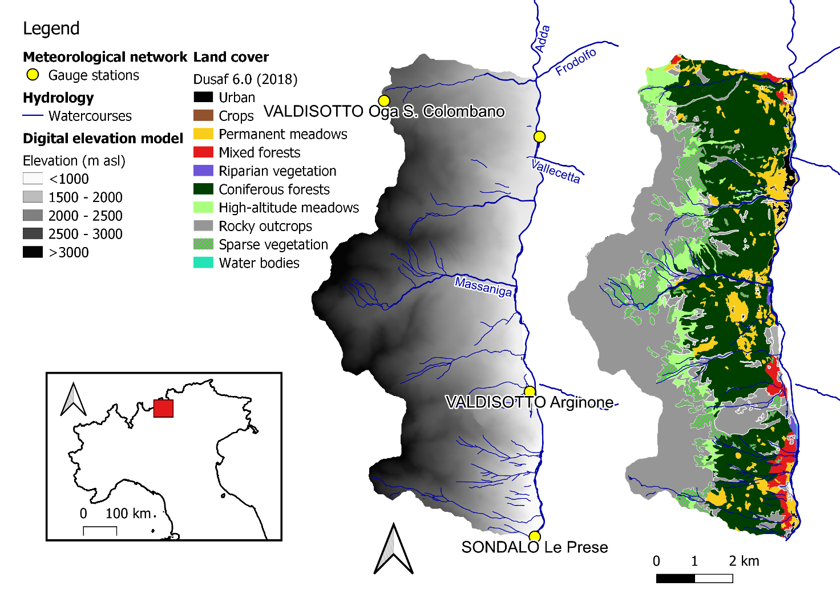
Figure 1. Description of study domain: location in the North Italy, elevation, position of meterological network, land cover and watercourses.

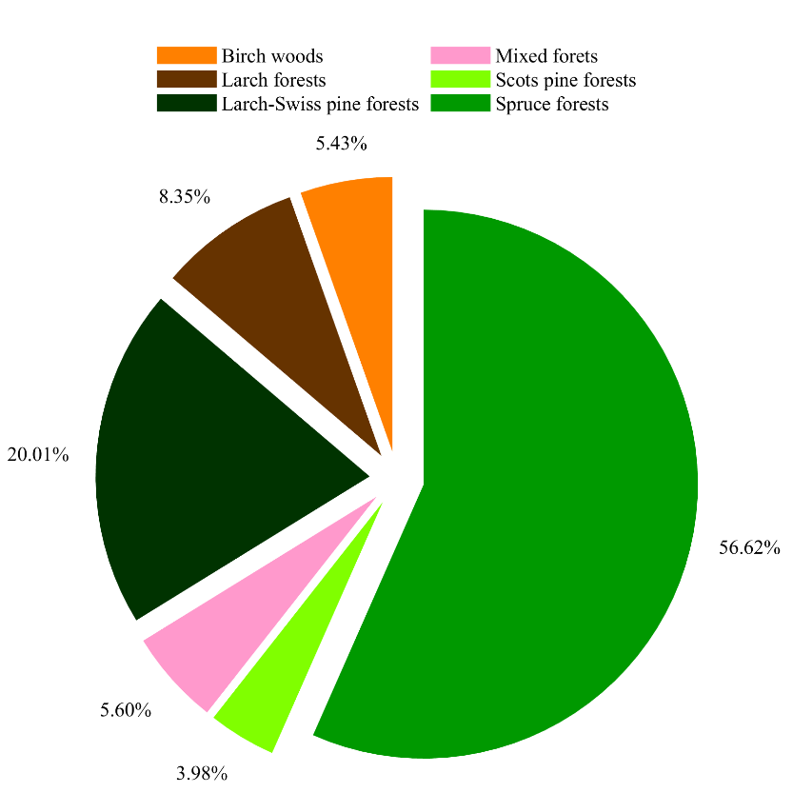
Figure 2. Distribution of tree species over the forest area in the study domain.
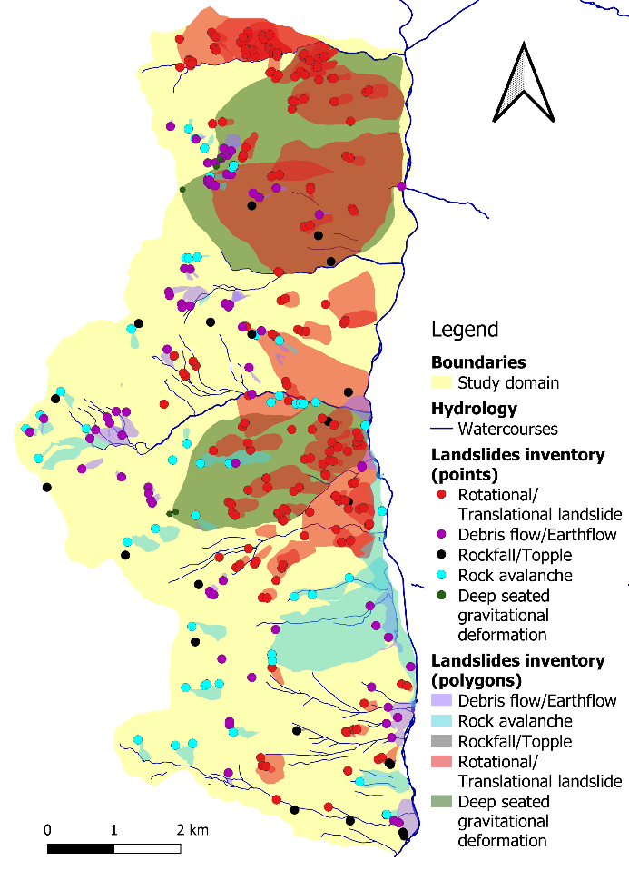
Figure 3. Landslides inventory (1980-2022).

Materials and methods

Field campaign
Forest measurements consisted in measuring forest stand characteristics such as tree density, DBH, height and basal area. These observations were conducted using the Bitterlich relascope (Austrian designer Walter Bitterlich) that is a multifunctional device that can be used to make an angle count sample to estimate basal area depending on basal area factor. In addition, it was coupled with a conventional clinometer. Then, species, forest cover type, DBH, and stem height were measured for all live trees inside each plot; species-specific and total tree volume (stem, branches, and foliage) was predicted as a function of DBH using national allometric models (Tabacchi et al., 2011). During the field campaign, we georeferenced the signs of past or ongoing natural disturbances (felled trees, rocks, erosion, landslide scarp, infested trees, etc.) to delimitate approximately the prone-natural hazard area.

Remote sensing techniques

Remote sensing data
We chose one high-quality image (cloud cover <5%) acquired from Sentinel-2 on 12 July 2021, i.e., at the peak of the growing season, and contemporary to the last forest survey in which field plots were measured for the calibration of biomass models (Vacchiano et al., 2018). The image was composed by 4 bands (B02, B03, B04, B08) with a ground resolution of 10 m, and 5 bands (B05, B06, B07, B11, B12) with a ground resolution of 20 m (Table 1).
Table 1.
Band number | Resolution | Central wavelength (nm) | Bandwidth (nm) | Reference radiance | SNR @ Lref
Unit of measure | m | nm | nm | W m⁻² sr⁻¹ μm⁻¹
B02 | 10 | 492.7 | 65 | 128 | 154
B03 | 10 | 559.8 | 35 | 128 | 168
B04 | 10 | 664.6 | 30 | 108 | 142
B08 | 10 | 832.8 | 105 | 103 | 174
B05 | 20 | 704.1 | 14 | 74.5 | 117
B06 | 20 | 740.5 | 14 | 68 | 89
B07 | 20 | 782.8 | 19 | 67 | 105
B11 | 20 | 1613.7 | 90 | 4 | 100
B12 | 20 | 2202.4 | 174 | 1.5 | 100

Statistical analysis on remote sensing data
Using these data, we performed a statistical analysis to model the relationships among spectral data (and other topographical data) and forest attributes, avoiding the possibility that these relationships may be non-linear and complex (Ingram et al., 2005). The 9 reflective Sentinel-2 bands commonly showed an inter-bands correlation that can be verified using the Pearson’s correlation coefficient. If the inter-bands correlation is markable, a principal component transformation was necessary to avoid the redundancy in further statistical analysis. The principal components that show an adequate cumulative variance were aggregated to other data (elevation, slope, aspect, produced by a 5m-resolution digital elevation model) and the Enhanced Vegetation Index (EVI) (Huete et al., 2002; Vacchiano et al., 2018). All these data were the input layers for the spatialization of the forest structural characteristics, in particular the tree density (trees ha⁻¹).

Spatialization

Spatialization of forest structural characteristics
Spatialization of forest structural characteristics consists in modelling the relationship between the remote sensing-derived data and the forest attributes. In forest science, although these relationships are often non-linear and complex (Ingram et al., 2005), many studies predicted an accurate biomass estimation using parametric and non-parametric models (Lu et al., 2016). In this study, we used a tree-based model called Random Forests (RF) (Breiman, 2001). The tree-based models perform recursive partitioning of dataset without specific assumptions regarding the distribution of the input samples and find non-linear relationships between response and predictor variables. In specific, RF divides the dataset into many homogenous subsets called regression trees (“trees”) and then averages the results of all trees. At each tree, splitting is performed using a randomly selected sub-set of the predictor variables. The resulting model is more accurate and less sensitive to noise in input data relative to conventional tree-based modeling algorithms (Maindonald and Braun, 2003; Prasad et al., 2006). We used the RF library “randomForest”, a R-package that implements the classification and regression approaches developed by Breiman (2001) (Liaw and Wiener, 2022). The model requests two parameters (the number of variables and the number of tress) that can vary based on the user decisions and as consequence have to be optimized for a more robust result (Gislason et al., 2006; Pal, 2005). Following the recommendations of Prasad et al. (2006), we used all the possible input variables as number of variables, whereas we evaluated the RF performance in function of the number of trees, testing the values from 500 to 2000.
The RF results were validated through a leave-one-out cross validation method (Brovelli et al., 2008; Kohavi, 1995). This assessment of the performance was achieved by dividing the data into k samples (k = total number of samples used for the analysis), and then the samples were removed one by one. The model was calibrated k times using all k samples, except for the omitted one, and used to predict the removed one. One-to-one relationships between measured and predicted values were established and the performance indexes were calculated. In the present study, we used the following performance indexes: mean absolute error (mae), mean absolute percentage error (mape), maximum absolute error (maxe), median absolute error (med.ae), mean square error (mse), mean square logarithmic error (msle), explained variance score (evs), and root mean square error (rmse).

Spatialization of damaged areas by windthrow or beetle attack
The areas damaged by Vaia windstorm were detected comparing the satellite images of 2008 and 2009. This data is available on the website of Lombardy region (https://www.geoportale.regione.lombardia.it/). The infested areas colonized by bark beetle outbreaks were detected though a field campaign focusing on the infestation symptoms defined in the scientific literature (Kautz et al., 2022).

Environmental Benefits indexes (EBi)
Environmental benefits indexes (EBi) are a set of indicators to quantify the impacts of water stewardships activities on water-related risks over time. The selected indicators were estimated as difference between the reference condition, i.e., 2018 pre-Vaia storm, and the actual or future scenario. All the indicators are results of different model or procedure and were exclusively applied over the portion of domain covered by forest where it is possible to design countermeasures to reduce and mitigate natural hazards or to slow down the bark beetle outbreaks.

Runoff simulation model
In the Sixties, the U.S. Department of Agriculture Soil Conservation Service (nowadays, known as Natural Resources Conservation Service) developed the homonymous Soil Conservation Service - Curve Number (SCS-CN) method, a rainfall-runoff model to compute the direct surface runoff (United States Department of Agriculture, 1972). This hydrological approach is based on the water balance equation that equalizes the ratio of actual amount of direct surface runoff ($Q$ in mm) to the total rainfall ($P$ in mm) (or maximum potential surface runoff) with the ratio of the amount of actual infiltration ($F$ in mm) to the amount of the potential maximum retention ($S$ in mm).
$\frac{Q}{P}=\frac{F}{S}$ (Eq. 1)
$P$ is reduced by the initial abstraction ($I_{a}$ in mm) that accounts for the short-term losses such as interception, surface storage and infiltration. In fact, when $P$ is higher than $I_{a}$, the direct surface runoff occurs ($Q$>0), otherwise $Q$=0. Integrating this assumption, Eq. (1) assumes the general formulation above:
$Q=\left\{\begin{aligned}0 , &P<I_{a} \\ \frac{{\left(P-I_{a}\right)}^{2}}{P+S-I_{a}}, &P≥I_{a}\end{aligned}\right.$ (Eq. 2)
where $I_{a}$ is a portion of $S$ as follows:
$I_{a}=λ∙S$ (Eq. 3)
where $λ$ is a regional parameter that depends on geologic and climatic factors and assumes a value ranging from 0.05 and 0.2 for practical applications, whereas $S$ is strictly related to the soil properties, the land cover (or rather the soil-vegetation system), and the antecedent soil moisture condition (AMC) prior to the rainfall event. These dependencies are integrated into a dimensionless parameter, the Curve Number (CN) as described in Eq. 4.
$S=S_{0} \left(\frac{100}{CN}-1\right)$ (Eq. 4)
where CN varies from 0 to 100 (where the minimum value represents an infinitely abstracting storage capacity, whereas the maximum one an impervious surface), and $S_{0}$ is a factor scale equal to 254 mm (i.e., 10 inches). CN values are in function of AMC, hydrological soil properties, and land cover as shown in the tables in the Supplementary Materials. In addition, the Volumetric Water Benefits (VWB) related to the restoration activities were estimated as the difference between the scenario without restoration and the scenario with restoration.

Shallow landslide susceptibility model
The assessment of shallow landslide susceptibility was conducted using the PRobabilistIc MUltidimensional shallow Landslide Analysis (PRIMULA), a slope stability model, recently developed by Cislaghi et al. (2017). The model combines a three-dimensional limit equilibrium model and a Monte Carlo Simulation and is based on several assumptions: (i) the force balance is estimated at the center of a potential landsliding soil block, (ii) groundwater level is steady and parallel to the slope surface; (iii) rainfall and infiltration processes cause the subdivision of the single block into saturated and unsaturated zones, neglecting the transitional zone. PRIMULA also includes earth pressure lateral forces, soil cohesion, and the reinforcing effects provided by root systems acting on potential landslide boundaries. For each landsliding block, the factor of safety (FS) can be evaluated as the ratio between resisting and driving forces as follows:
$FS=\frac{F_{rb}+2∙F_{rl}+F_{rd}+F_{ru}-F_{du}}{F_{dc}}$ (Eq. 5)
where the driving forces consist of the downslope component of the central block mass ($F_{dc}$), whereas the force on the central block acting from the upslope wedge ($F_{du}$) assuming an active earth condition; the resisting forces acting on all boundaries of the block are caused by passive earth pressure from the downslope wedge ($F_{rd}$), the basal resistance force ($F_{rb}$), the shear resistance on two parallel slope sides of the element ($F_{rl}$), and the root reinforcement acting on the upslope side ($F_{ru}$). In Supplementary materials, a comprehensive description of each equation was reported, and more details are in Cislaghi et al. (2017). PRIMULA requires several parameters, not as single values but as a probability distribution function to include their stochastic variability. The parameters are: (i) the size of the potential landsliding block, width $w$, length $l$, and hillslope inclination $θ$; (ii) the geotechnical soil properties, the unit weight of soil $γ_{s}$, effective soil friction angle $φ'$, the failure depth $z$, the saturated hydraulic conductivity $Ks$, and the effective soil cohesion $C_{s}^{'}$; (iii) the maximum daily precipitation in function of return period; and (iv) the root reinforcement in terms of additional basal and lateral root cohesion $C_{rb}^{'}$ and $C_{rl}^{'}$, respectively.
These last two factors were evaluated using rootFORCE (Cislaghi et al., 2021) that requests the forest stand characteristics (tree density, tree dominant species, and DBH) and the forest types as input parameters.
The output of PRIMULA is not a single value of FS, but the probability of failure (i.e., the probability that FS is less than 1) for each cell of the entire domain.

Additional absorption of CO₂
All forests are capable of absorbing CO₂ through photosynthesis. In 2021, global forests absorbed 29% of anthropogenic CO2 emissions (https://www.globalcarbonproject.org/carbonbudget/), a ratio that drops to about 9% if we consider absorption and emissions on the Italian territory (https://www.isprambiente.gov.it/it/pubblicazioni/rapporti/italian-greenhouse-gas-inventory-1990-2020-national-inventory-report-2022). However, forest ecosystems can also emit carbon, as occurs during and after a disturbance, due to direct emissions from the combustion or decomposition of wood, indirect emissions generated by increased respiration of bare soil, and loss of potential absorption in the initial stages of forest reconstitution. All management interventions capable of increasing absorption or reducing losses with respect to business-as-usual ("additional") are considered carbon positive and could - in the presence of legislation that allows it - generate carbon credits in favor of the subjects that carries out the interventions. Credits can be transacted on voluntary or mandatory markets according to national and international legislation.
In Italy, under the Kyoto Protocol it was not possible to generate carbon credits deriving from sustainable forest management or other activities in areas already classified as forest, because all the carbon sink (baseline and additional) were claimed by the State, which counted them ex post through the National Forest Inventory and did not allow them to be double counted by other subjects. The reporting period of the Kyoto protocol, however, ends in 2022; by the end of the year, an inter-ministerial decree is expected to regulate the generation and transaction of “climate credits” on the voluntary market (non-ETS sectors) deriving from sustainable forest management. The decree will regulate the criteria of additionality and permanence (probably from a minimum of 30 to a maximum of 100 years) necessary for the generation of credits and their subscription into a national register, in order to avoid double counting. The credits thus generated can be used on an exclusively national voluntary market (seller and buyer both based in Italy).
Even without the actual generation of marketable credits, a company may be interested in calculating the benefit of the interventions it supports in terms of CO₂ absorption, communicating this information in Corporate Social Responsibility activities or in other communication activities. It is necessary to remember that also in this case the estimates must be calculated observing the principle of additionality, and that the company activity should first focus on the avoidance or reduction of emissions at the source, considering "offsets" only as a last resort for the achievement of climate neutrality according to a path compatible with the objectives of the Paris Agreement (https://sciencebasedtargets.org).

Results

Field data
The relascopic measures were conducted in 179 sampling plots subdivided in 32 parcels. The measurements showed a quite homogeneous forest stand, except for the portion devasted by Vaia storm (Figure 4.). On average, the mean tree density approximately varies from 200 to 370 trees per hectare. The average wood volume is 386 m³ per hectare, while the basal area is 38.5 m² per hectare.
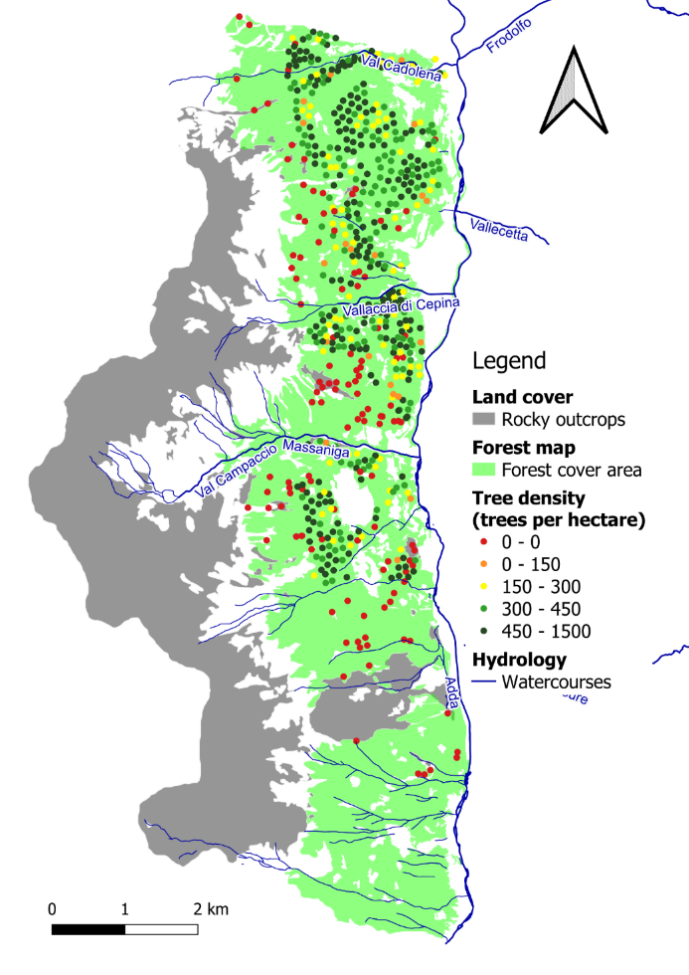
Figure 4. Map of relascopic measurements.

Meteorological data
Four meteorological stations (Figure 5) are situated within the study domain at different elevations. All stations monitored the hourly precipitation, whereas three of them monitored the temperature. In the last 10 years, the mean annual temperature is around 8.80°C and 2.08°C, at 1000 m and 2300 m asl, respectively. The mean annual precipitation is around 1000 mm over the entire study domain. The elevation exacerbates the difference in terms of temperature with an offset of approximately 6°C every 1000 m of elevation.
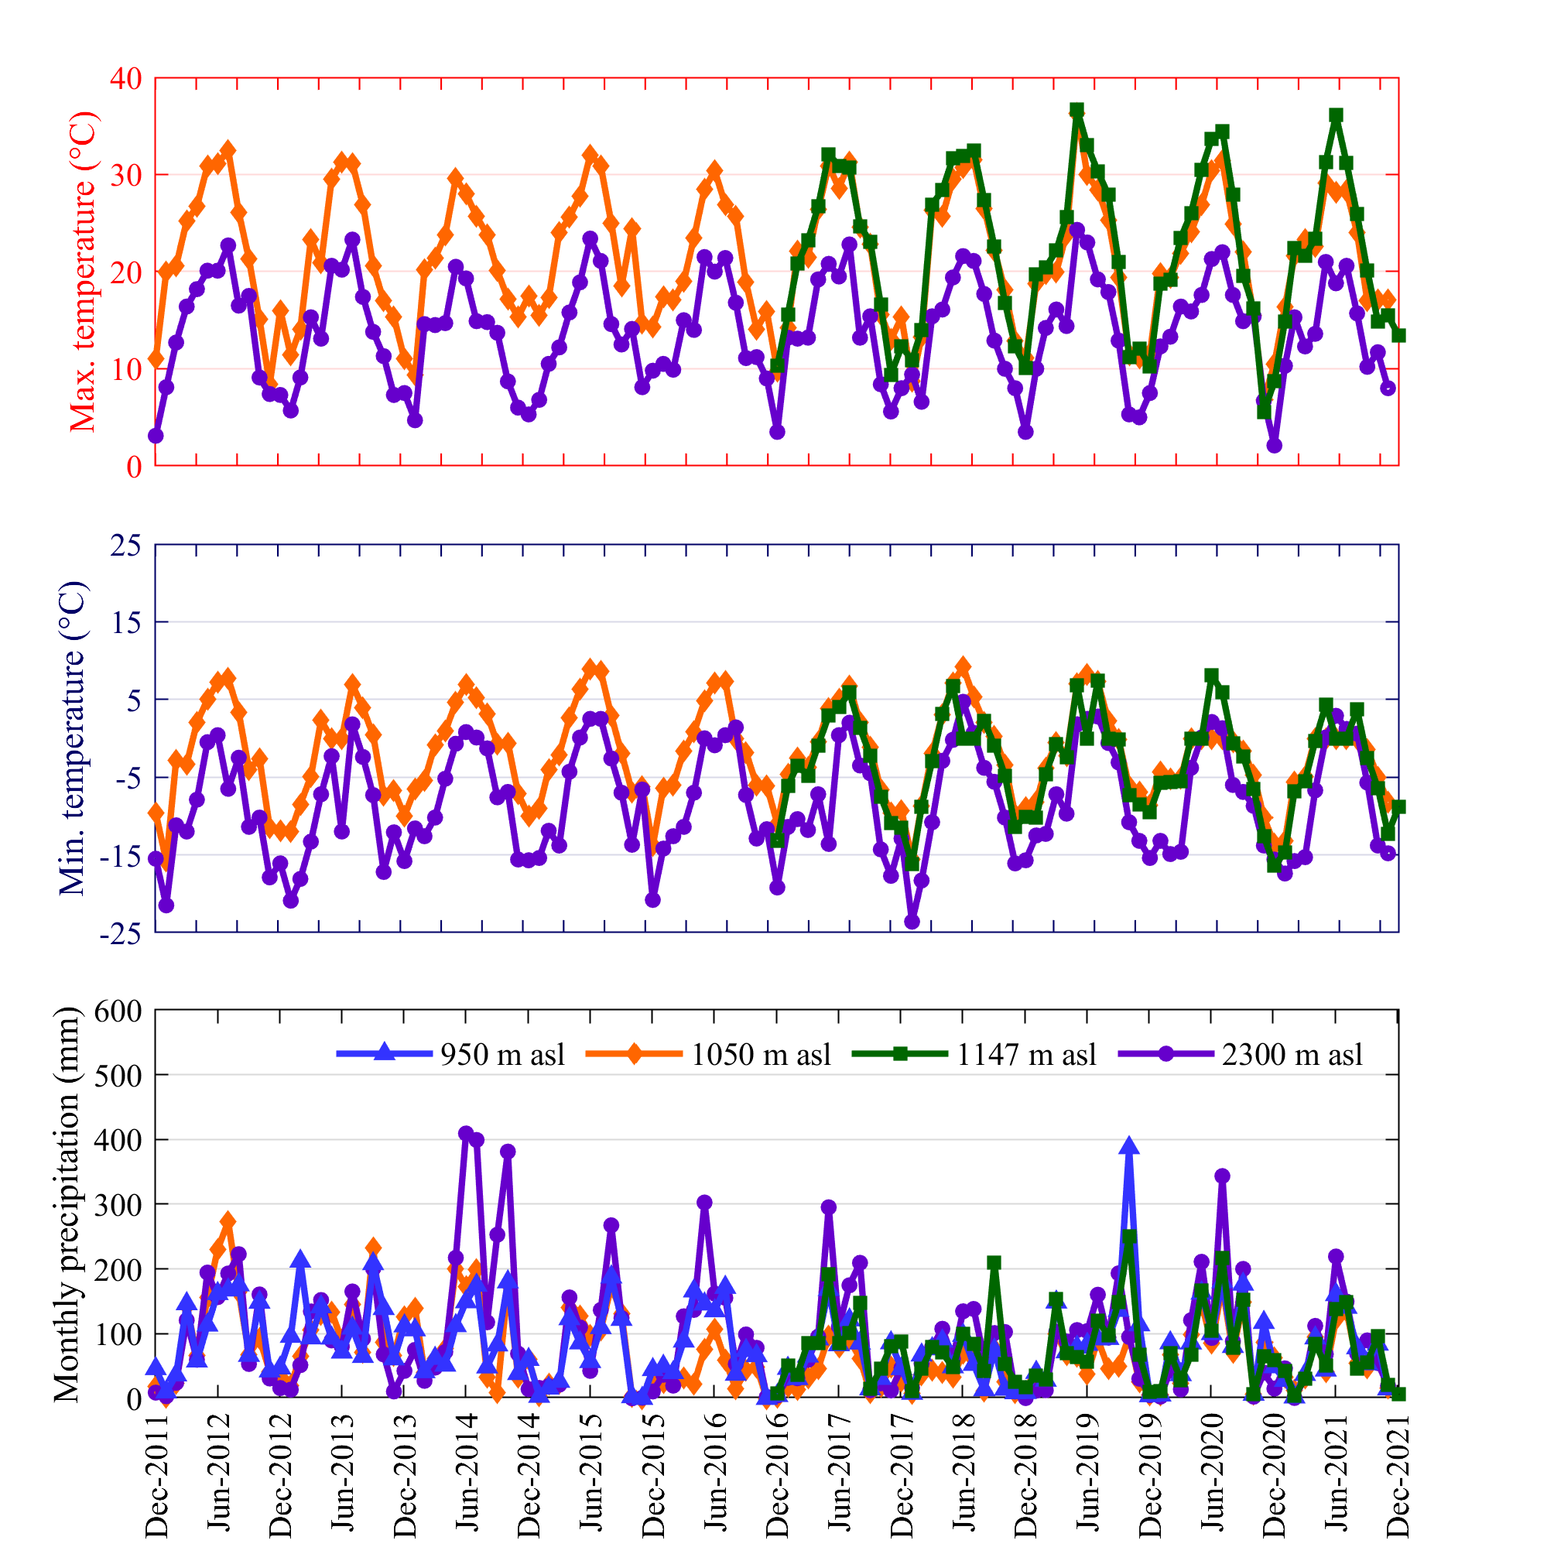
Figure 5. Time-series observations of minimum temperature, maximum temperature and monthly precipitation.

Remote sensing data

Statistical analysis on remote sensing data
The Pearson’s correlation coefficient showed an inter-bands moderate-high correlation as verified using the Pearson’s correlation coefficient (Table 2). It is evident a markable correlation within the visible and near-infrared (VNIR) and within the Short-wave infrared (SWIR).
Table 2. Pearson’s correlation coefficient
 | B02 | B03 | B04 | B08 | B05 | B06 | B07 | B11 | B12
B02 | - | 0.99 | 0.99 | 0.95 | 0.57 | 0.37 | 0.33 | 0.09 | 0.27
B03 | 0.99 | - | 0.99 | 0.96 | 0.60 | 0.40 | 0.36 | 0.13 | 0.31
B04 | 0.99 | 0.99 | - | 0.96 | 0.54 | 0.33 | 0.28 | 0.16 | 0.36
B08 | 0.95 | 0.96 | 0.96 | - | 0.68 | 0.48 | 0.41 | 0.20 | 0.35
B05 | 0.57 | 0.60 | 0.54 | 0.68 | - | 0.96 | 0.90 | 0.10 | -0.01
B06 | 0.37 | 0.40 | 0.33 | 0.48 | 0.96 | - | 0.95 | 0.07 | -0.12
B07 | 0.33 | 0.36 | 0.28 | 0.41 | 0.90 | 0.95 | - | 0.08 | -0.12
B11 | 0.09 | 0.13 | 0.16 | 0.20 | 0.10 | 0.07 | 0.08 | - | 0.93
B12 | 0.27 | 0.31 | 0.36 | 0.35 | -0.01 | -0.12 | -0.12 | 0.93 | -

To overcome redundancy, the 9 Sentinel-2 reflective bands were summarized by principial components with a cumulative variance explained equal to 100% (Table 3). The first component was dominated by one of the wider SWIR bands (B11), whereas the second component by Near Infra-Red band (B08), one of the VNIR vegetation red edge spectral domain (B07) and the other one of the wider SWIR bands (B12).
Table 3. P rincipal component analysis of Sentinel-2 reflective bands.
 | PCA.1 | PCA.2 | PCA.3 | PCA.4 | PCA.5 | PCA.6 | PCA.7 | PCA.8 | PCA.9
B02 | 0.43 | 0.22 | 0.15 | 0.26 | 0.32 | 0.64 | 0.29 | 0.25 | 0.14
B03 | 0.45 | 0.20 | 0.22 | 0.11 | -0.22 | -0.76 | -0.26
B04 | 0.47 | 0.28 | 0.11 | -0.64 | -0.16 | 0.50
B05 | 0.43 | 0.12 | -0.57 | -0.61 | 0.13 | 0.25 | -0.14
B06 | 0.30 | -0.40 | -0.35 | 0.17 | 0.24 | -0.68 | 0.27
B07 | 0.24 | -0.54 | -0.24 | 0.47 | -0.28 | 0.52 | -0.10
B08 | 0.23 | -0.57 | 0.60 | -0.50
B11 | -0.78 | 0.11 | 0.14 | -0.12 | 0.19 | -0.54
B12 | 0.19 | -0.58 | 0.16 | -0.26 | 0.72
SD | 2320.36 | 1310.31 | 845.44 | 296.99 | 151.96 | 78.55 | 70.97 | 55.50 | 53.79
Variance (%) | 67.77 | 21.61 | 9.00 | 1.11 | 0.29 | 0.08 | 0.06 | 0.04 | 0.04
Cum. Variance (%) | 67.77 | 89.39 | 98.38 | 99.49 | 99.78 | 99.86 | 99.92 | 99.96 | 100.00

RF algorithm was fed by the output of the PCA analysis, DEM-derived (elevation, slope, aspect), and the EVI. All input data are aggregated or disaggregated to obtain 10-m resolution raster. RF produces a raster of tree density with values ranging from 0 to 1000 trees ha⁻¹ (Figure 6). The median and mean values (± standard deviation) are 352.8 and 320.2 ± 158.1 trees ha⁻¹ (Figure 7). The performance of RF method showed a robust accuracy (Table 4): the values of mape are around 15.4% and 32.7% with an average error of 62.2 and 132.8 trees ha⁻¹ in calibration and validation, respectively. The maximum discrepancies are more evident where the forest is more heterogeneous with a significant presence of broadleaves.
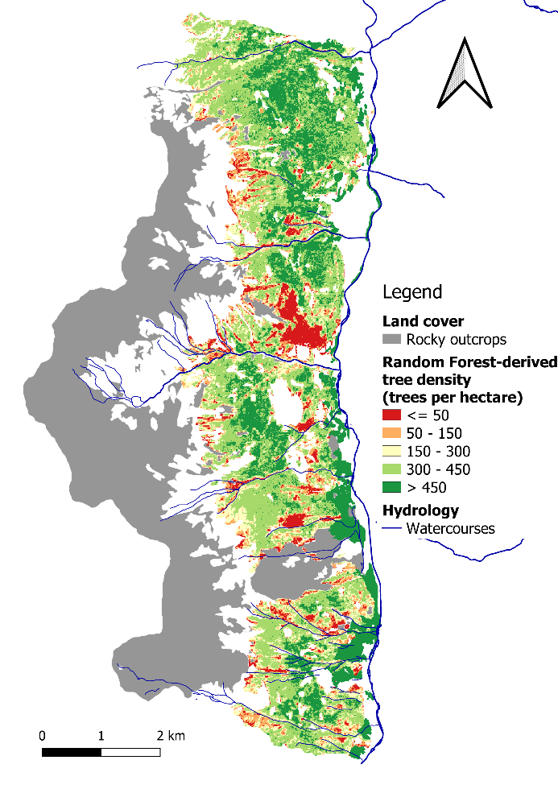
Figure 6. The output of Random Forest in terms of predicted tree density (trees per hectare).

Table 4. Performance of RF method in calibration and validation.
 | mae | mape | maxe | med.ae | mse | msle | evs | rmse
 | trees ha⁻¹ | % | trees ha⁻¹ | trees ha⁻¹ | trees² ha⁻² | - | - | trees ha⁻¹
Calibration | 62.24 | 15.37 | 497.02 | 50.39 | 6892.05 | 1.19 | 0.89 | 83.02
Leave-one-out validation | 132.80 | 32.73 | 1055.50 | 130.12 | 39837.37 | 2.11 | 0.36 | 199.59

Figure 7. Measured vs. predicted tree density.
Figure 8. Measured tree density vs. difference between predicted and measured tree density.

Identification of vulnerable areas
The Vaia windstorm (26-30 October 2018) damaged around 1.42 km² of forest area. The combination between aerial photographs, remote sensing vegetation indices, and field observations allow to detect approximately 80 polygons partially or completely covered by felled trees (Figure 9). Their areas range from 177 m² to 0.43 km² with an average value of 0.02 km². The greater damaged-forest area is situated along the left side of the Massaniga torrent. Since the following spring, the bark beetle attack began the main problem of the entire study domain (Figure 10). During the further years, most felled wood in the northern part of study domain was removed freeing the hillslope. The field observations in the summer 2022 showed the felled trees were removed over an area of 0.64 km² especially where the forestry machinery could work in safety (Figure 10). Despite these efforts, more than 50% were lying on the ground, especially in the remote areas where the forest machinery cannot reach. In addition, recent moderate windstorms (2019-2022) damaged approximately 0.22 km² more. Moreover, in the last 4 years, the field observations made evident the fast expansion of the bark beetle attack that hits an area of 0.22 km².
a)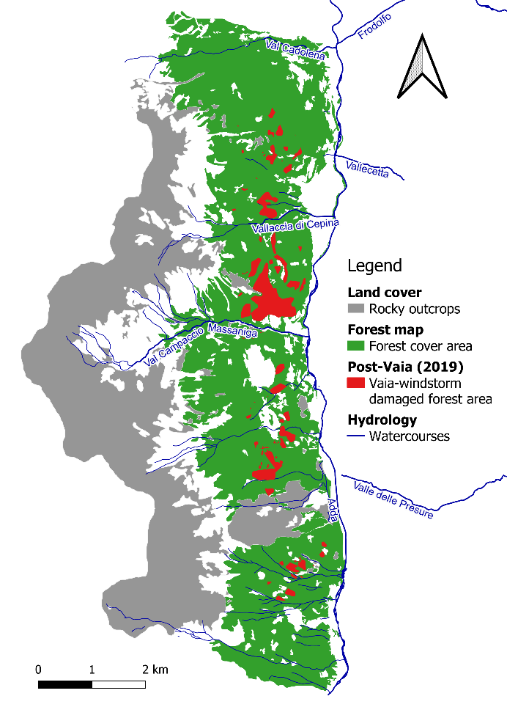b)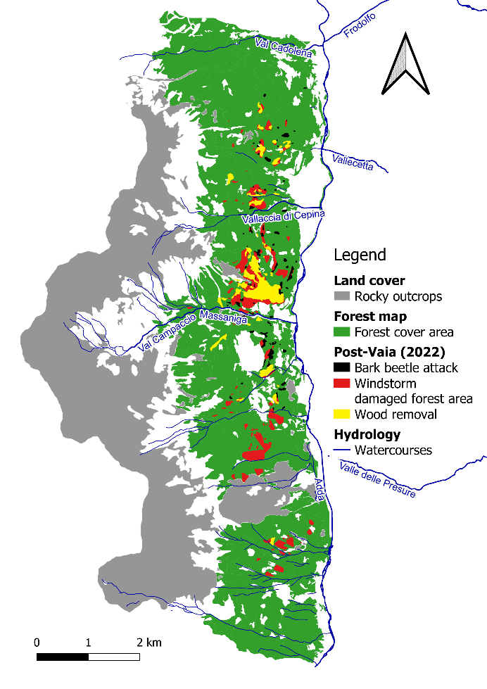
Figure 9. a) Detection of Vaia windstorm damaged areas over a forest map in 2019; b) updated detection in 2022 showing windstorm damaged areas (where felled trees were lying on the ground and recent windstorm damaged), and areas characterized by bark beetle attack and wood removal that requests a forest restoration
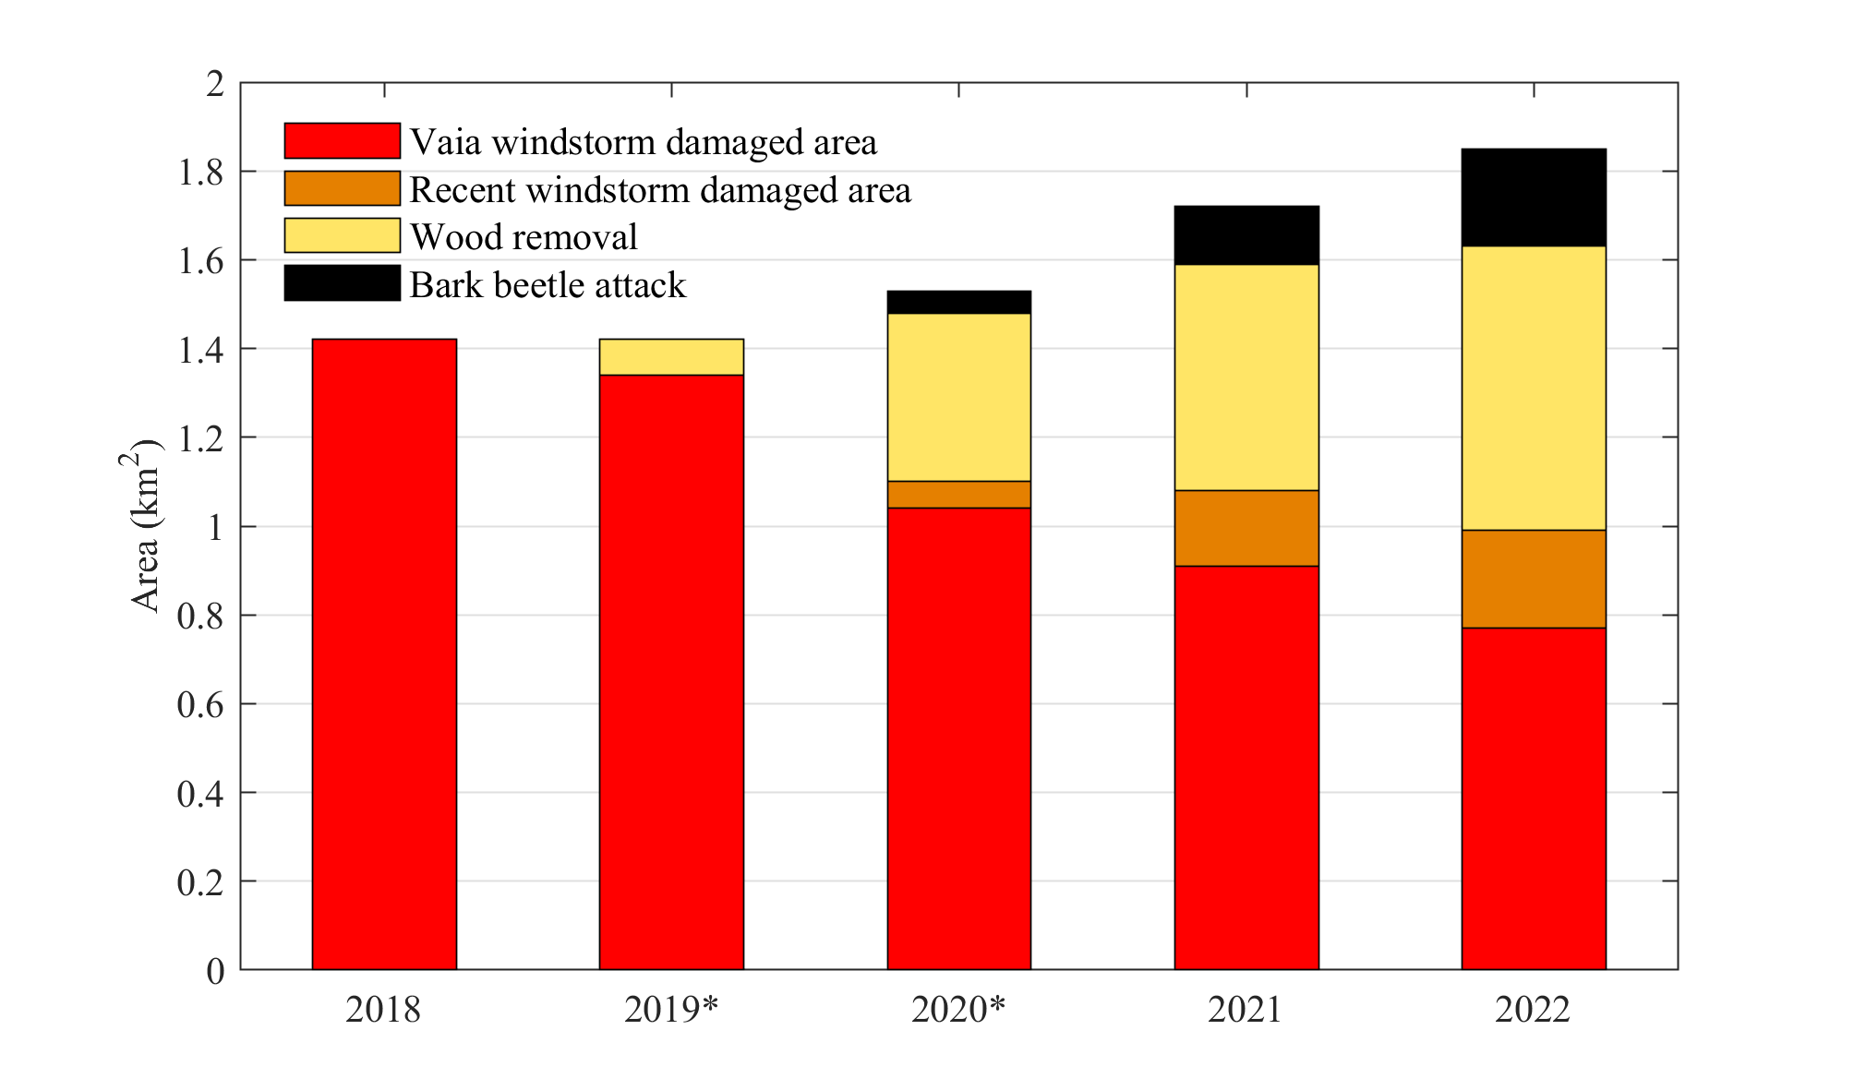
Figure 10. Temporal distribution of areas in function of land cover change. The asterisks indicates that the data are estimated from airborne and satellite images.

Baseline scenarios
The EBi assume an important meaningful if estimated over the time. To follow this objective, it is clear that the assessment of possible evolution of the present condition is necessary. In the present case, the uncertainties are strictly linked to the bark beetle infestation. Bark beetle infestation has been recognized as one of the most relevant threats for the forest environment, especially during the recent years. The efforts of the scientific community dated back the beginning of the Eighties, despite few studies dealt with the topic through a constant monitoring (Ravn, 1985).
The future scenarios, in this case, were obtained following a step-by-step procedure consisting of: (i) review of the scientific literature dealing with a specific topic, i.e., bark beetle infestation in European forests; (ii) exploration of time-series monitored infestation; (iii) modelling the expansion of the populations of Ips typographus (L.) through a logistic function (Wulder et al., 2006); and (iv) estimation of future scenarios at different future time-period.
Ips typographus is one of the most destructive xylophagous insect, causing extremely dangerous infestation over coniferous forests in Europe, especially those dominated by the presence of Norway spruce (Picea abies). The first signs of bark beetle attacks were dated back approximately a century ago (Blackman, 1924; Craighead, 1925; Wermelinger, 2004). The bark beetle outbreaks cause significant damage to the forest as serious as the external condition are favorable. Bark beetle population growth accelerates when drought and high temperature occur. In fact, higher temperatures imply more completed generation cycles per year, the spread to higher altitudes, and also to higher latitudes. Conversely warm temperatures in summer increase the population growth of bark beetles (Stadelmann et al., 2013; Wermelinger and Seifert, 1999), whereas lower temperatures in winter entail increased winter mortality (Faccoli, 2002). In addition, the precipitations influence bark beetle dispersal because adult bark beetle only swarm during dry weather (Craighead, 1925), and a drought in spring or early summer weakens the drought-intolerant Norway spruce and thus enhances host susceptibility (Baier et al., 2007; Faccoli, 2009). Other favorable conditions occur after extremely destructive events such as snowfall and windthrow (that caused the falls of trees). Indeed, major windthrows provide large amounts of breeding material, can trigger large-scale outbreaks, resulting in widespread mortality of healthy trees (Biedermann et al., 2019; Kausrud et al., 2011; Marini et al., 2017), often clustered in space and time (Chapman et al., 2012; Stadelmann et al., 2014). The peak of the bark beetle epidemic usually occurs in the second or third summer after the forest disturbance and is evident in an exacerbated desiccation process of the bark. Meanwhile, the outbreak spread largely depends on the forest structure, forest age, insect abundance, tree susceptibility, weather conditions, and human adopted countermeasures (Stadelmann et al., 2013; Wermelinger, 2004).
In this context, the Norway spruce is the tree species most affected by this threat. Spruce is the tree with a major economic interest in Europe (Grégoire et al., 2015), and, growing in monocultures as promoted by forests in the last century (Hlásny et al., 2019), it is subject to a high susceptibility to insect infestation. Between 2002 and 2010, 14.5 million of m³ of timber were annually affected by bark beetle disturbance (Seidl et al., 2014).
Although the evidence of the damage due to bark beetle attack and the efforts of scientific community dedicated to this topic were significant, few data are available to draw robust conclusions. Few studies showed a clear and natural development of Ips typographus outbreaks, despite in many cases control measures were adopted and/or other extreme events occur. Some of them are summarized in the following paragraph.

Table 5. Literature review on studies monitoring bark beetle spread.
Reference | Study site | Insect | Dominant species | Period | Variable | Methods
Colombari et al. (2013) | Dolomites (N-Italy) 2100 ha | Ips acuminatus | Scots pine | 2006-2010 | Number of trees | Field campaign
Georgiev et al. (2022) | Western Balkan Range (Bulgaria) 314 ha | Ips typographus | Norway spruce | 2011-2020 | Infested area | Remote sensing (drone, airborne and satellite)
Georgieva et al., (2022) | Eastern Rhodopes (Bulgaria) | Ips acuminatus | Scots pine and black pine | 2011-2020 | Infested area | Remote sensing (drone)
Kautz et al. (2011; Müller et al. (2008) | Bavarian Forest National Park (SE-Germany), Šumava National Park (SW-Czech Republic) 10700 ha | Ips typographus | Norway spruce | 1988-2009 | Infested areas | Remote sensing (airborne)
Marini et al. (2012) | Friuli-Venezia Giulia (NE-Italy) 64200 ha | Ips typographus | Norway spruce | 1994-2009 | Timber loss | Field campaign
Mezei (2017) | Tatra Mountains (N-Slovakia) 2980 ha | Ips typographus | Norway spruce | 1988-2012 | Timber loss | Remote sensing (satellite)
Migas-Mazur et al. (2021) | Tatra Mountains (N-Slovakia and S-Poland) 22300 ha | Ips typographus | Norway spruce | 2015-2018 | Infested area | Remote sensing (satellite)
Nardi et al. (2022) | Belluno Province (NE-Italy) 500 ha | Ips typographus | Norway spruce | 2016-2020 | Infested area | Remote sensing (satellite)
Stadelmann et al. (2014) | Napf region (C-Switzerland) 9000 ha | Ips typographus | Norway spruce | 1999-2011 | Infested area | Field campaign
Forster et al. (2003) | Switzerland | Ips typographus | Norway spruce | 1984-2001 | Timber loss | Field campaign
Bakke (1983) | Hedmark county (S-Norway) | Ips typographus | Norway spruce | 1971-1982 | Timber loss | Field campaign
Bakke (1983, 1989) | Telemark county (S-Norway) | Ips typographus | Norway spruce | 1978-1982 | Timber loss | Field campaign
Koreň et al. (2021) | Horní Planá region (Czech Republic) 16600 ha | Ips typographus | Norway spruce | 2003-2012 | Infested area | Remote sensing (satellite)
Havašová et al. (2017) | Tatransky Národny Park (N-Slovakia) | Ips typographus | Norway spruce | 2005-2014 | Infested area | Field campaign
Havašová et al. (2017) | Tatrzanski Park Narodowy (S-Poland) | Ips typographus | Norway spruce | 2005-2014 | Infested area | Field campaign
Kunca et al. (2019) | Slovak Republic | Ips typographus | Norway spruce | 1998-2017 | Timber loss | Field campaign

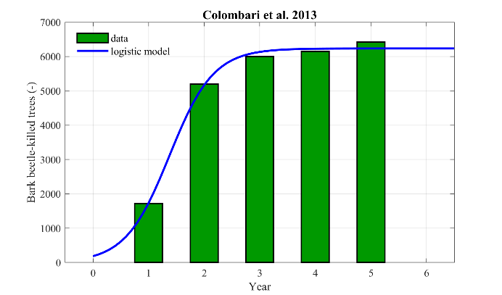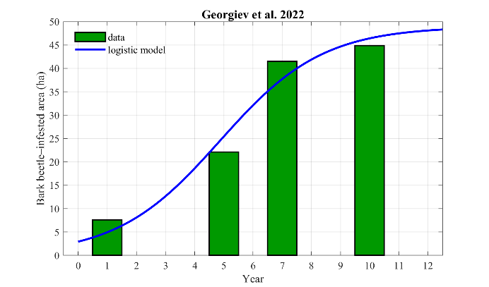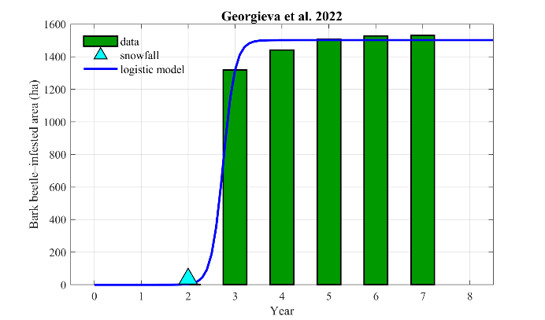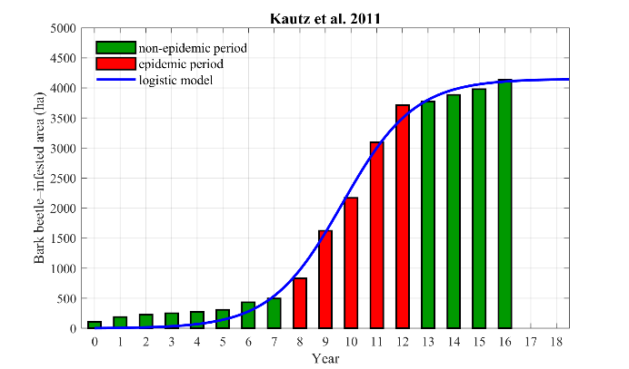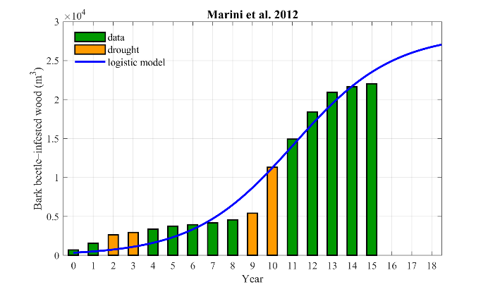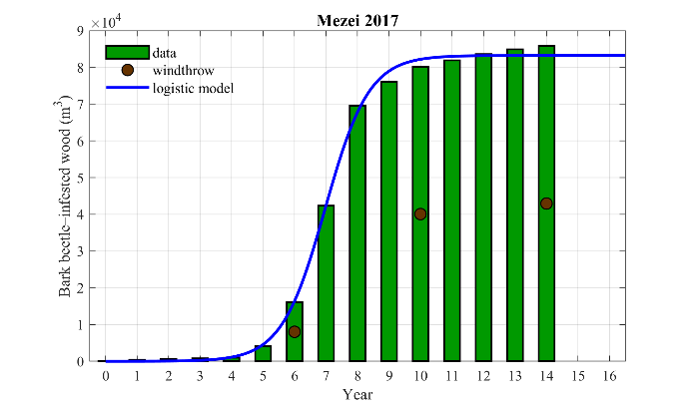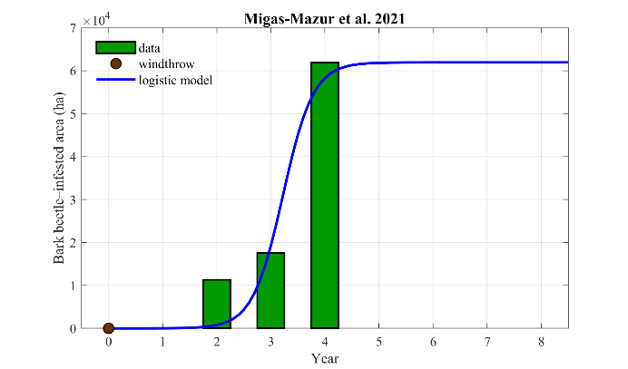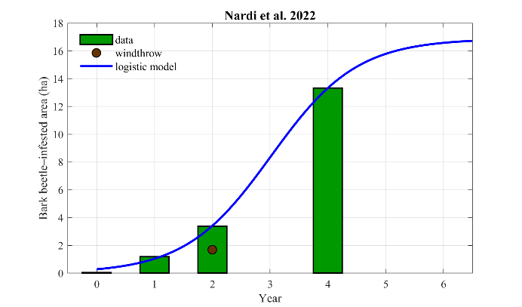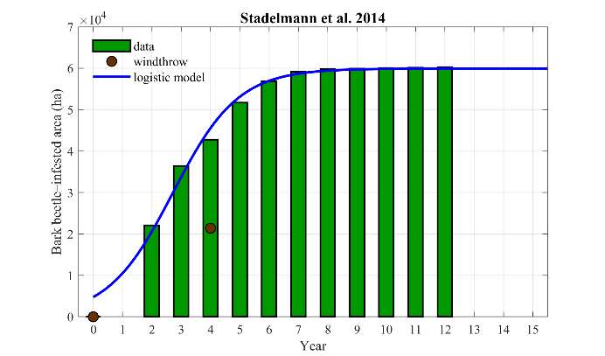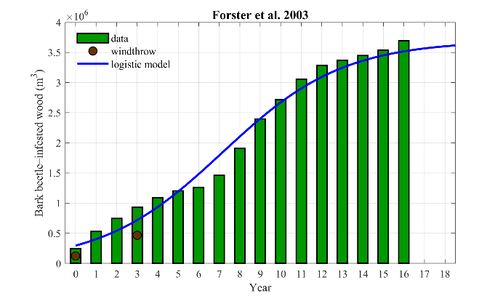
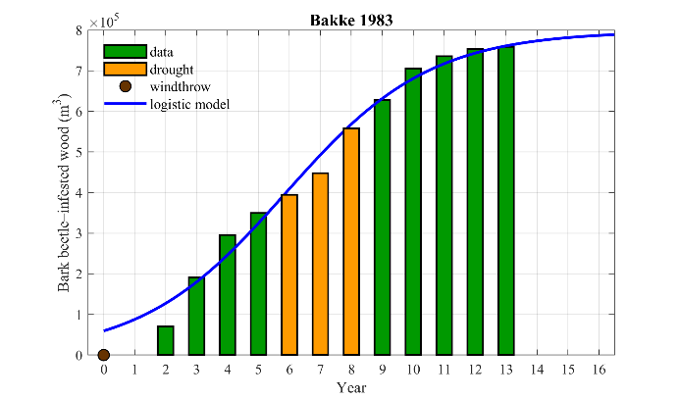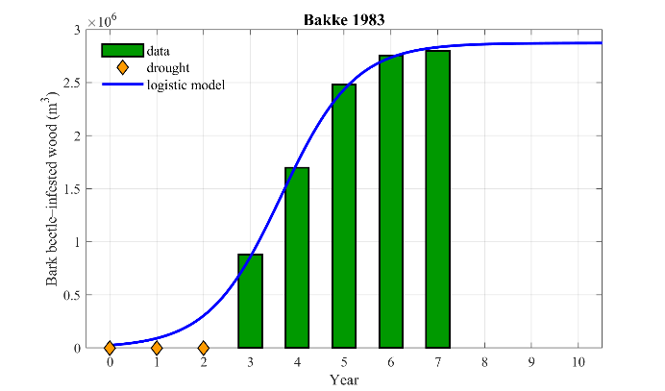
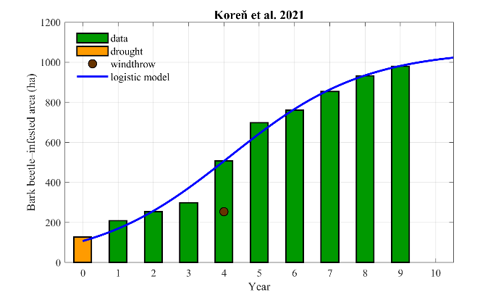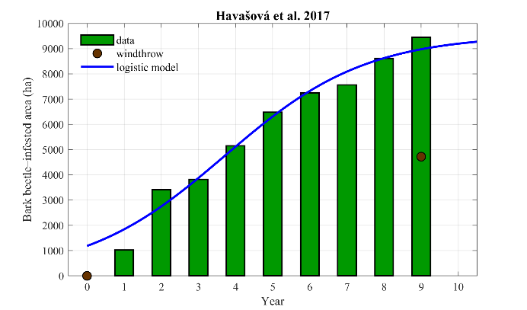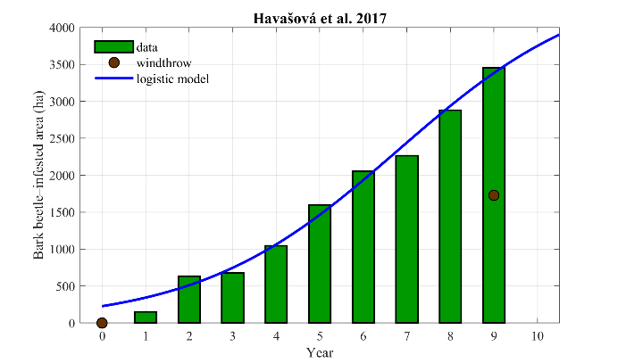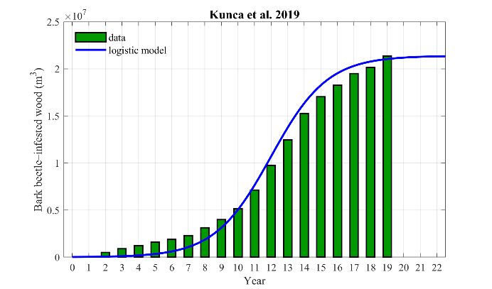
Figure 11. Graphical review of collected database with a fitted logistic function.
The collected dataset showed an extremely wide variability for several reasons. First, the observations were conducted monitoring different objects such as the infested area, the timber loss, the bark beetle population, etc. (Wulder et al., 2006). Second, the observations differ in the beginning condition and timing (e.g., they did not always start since the disturbance), and the length of these time-series is extremely different. Third, the external conditions were different both in terms of natural disturbance that exacerbates the bark beetle outbreak (snowfall, drought, windthrow, etc.) and in terms of climate conditions (e.g., increase of temperature). Despite these relevant uncertainties, the scientific literature agrees on the epidemic duration and on the extension of the bark beetle attack. In particular, the temporal epidemics last from 3 to 6 years, with an extension of 3-8 times more compared to the first detection of a bark beetle attack. The duration is evident fitting the data through a logistic function (Figure 11). On these bases, we proposed two future scenarios for 2025 at the end of the first epidemics and for 2035 at the end of the second epidemics, with three different severities. The mild scenarios consist in an expansion of 3- and 6-times respect than the first detection for 2025 and 2035 respectively. The moderate scenarios consist in an expansion of 5- and 10-times respect than the first detection for 2025 and 2035 respectively. Finally, the severe scenarios consist in 8- and 16-times respect than the first detection respectively. Such approximation is in agreement with several forecasts proposed in several studies (e.g., Potterf and Bone, 2017).
Table 6. Future scenarios
Year | Disturbance | Damaged area (ha) | Scenario
2017 | Pre-Vaia storm | 0 | Observed
2018 | Post-Vaia storm | 142 | Observed
2021 | Bark beetle infestation | 14 | Observed
2022 | Bark beetle infestation | 22 | Observed
2025 | Bark beetle infestation | 42 (3 times) | Mild
2025 | Bark beetle infestation | 70 (5 times) | Moderate
2025 | Bark beetle infestation | 112 (8 times) | Severe
2035 | Bark beetle infestation | 84 (6 times) | Mild
2035 | Bark beetle infestation | 143 (10 times) | Moderate
2035 | Bark beetle infestation | 224 (16 times) | Severe
2025 | Restoration | 99* | Moderate
2035 | Restoration | 131* | Moderate
*Restored area (ha)

Environmental benefits results

Runoff simulation results
The SCS-CN model was applied only over the forest area. The damages due to Vaia windstorm, the removal of felled trees, and the bark beetle infestation provide a land use change that influence the surface condition, and as consequence, the runoff generation. For this reason, the future scenarios take into account a different classification of land use. In terms of CN values, we assumed that:
- Scenario 2025 without restoration: the areas where the felled trees were removed were classified as “bare soils and sparsely vegetated areas” (Corine Land Cover = 333), whereas the infested areas by bark beetle outbreaks were classified as forest in poor condition (Table 7).
- Scenario 2035 without restoration: the areas where the felled trees were removed and the infested areas by bark beetle outbreaks were both classified as “bare soils and sparsely vegetated areas” (Corine Land Cover = 333).
- Scenario 2025 with restoration: the restored area was classified as “brush” in poor condition (Table 7).
- Scenario 2035 with restoration: the restored area was classified as “brush” in fair condition (Table 7).
The increase of direct runoff due to the denudation of the landscape after the Vaia storm was estimated to around 0.08 Mm³ year⁻¹ (Table 8). In the mild 2025- and 2035-scenarios, the direct runoff increases to 0.10 and 0.15 Mm³ year⁻¹, respectively. In the moderate 2025- and 2035-scenarios, the direct runoff increases to 0.12 and 0.19 Mm³ year⁻¹, respectively. In the severe 2025- and 2035-scenarios, the direct runoff increases to 0.17 and 0.24 Mm³ year⁻¹, respectively. The restoration activity, conversely, can significantly reduce the direct runoff to 0.05 and 0.02 Mm³ year⁻¹ in 2025 and 2035, respectively. Finally, the VWB in 2025 ranged from 0.05 to 0.12 Mm³ year⁻¹, in the mild and severe scenario of bark beetle outbreak, respectively. The VWB in 2035 significantly increased varying from 0.12 to 0.21 Mm³ year⁻¹ in the mild and severe scenario of bark beetle outbreak, respectively.

Table 7. Runoff curve numbers for forest and agricultural land (USDA National Resources Conservation Service, 1986).
Cover type | Hydrologic condition | Hydrologic soil group
Cover type | Hydrologic condition | A | B | C | D
Pasture, grassland, or range | Poor | 68 | 79 | 86 | 89
Pasture, grassland, or range | Fair | 49 | 69 | 79 | 84
Pasture, grassland, or range | Good | 39 | 61 | 74 | 80
Meadow (continuous grass) | - | 30 | 58 | 71 | 78
Brush | Poor | 48 | 67 | 77 | 83
Brush | Fair | 35 | 56 | 70 | 77
Brush | Good | 30 | 48 | 65 | 73
Orchard or tree farms | Poor | 57 | 73 | 82 | 86
Orchard or tree farms | Fair | 43 | 65 | 76 | 82
Orchard or tree farms | Good | 32 | 58 | 72 | 79
Woods | Poor | 45 | 66 | 77 | 83
Woods | Fair | 36 | 60 | 73 | 79
Woods | Good | 30 | 55 | 70 | 77
Farmsteads | - | 59 | 74 | 82 | 86

Table 8. SCS-CN simulations in fucntion of different future scenarios and compared to pre-Vaia condition (minimum direct runoff).
Year | Disturbance | Scenario | Damaged area/Restored area | ΔQ (m³ year⁻¹)
2018 | Pre-Vaia storm | Observed | 0 | 0
2019 | Post-Vaia storm | Observed | 142 | +62,520
2022 | Bark beetle infestation | Observed | 22 | +82,180
2025 | Bark beetle infestation | Mild | 42 (3 times) | +96,925
2025 | Bark beetle infestation | Moderate | 70 (5 times) | +125,172
2025 | Bark beetle infestation | Severe | 112 (8 times) | +169,786
2035 | Bark beetle infestation | Mild | 84 (6 times) | +146,075
2035 | Bark beetle infestation | Moderate | 143 (10 times) | +192,133
2035 | Bark beetle infestation | Severe | 224 (16 times) | +236,541
2025 | Restoration | Restored | 99 | +47,735
2035 | Restoration | Restored | 110 | +24,888

Shallow landslide susceptibility results
The outcome of rootFORCE produced a map of the lateral root reinforcement $C_{rl}^{'}$ () where the forested area showed a variability of value from 2000 to 12000 Pa. The lower values are concentrated where Vaia storm completely devasted the forests, where the higher values are located in the steepest hillslope in proximity of the Vallaccia di Cepina and the Val Cadolena torrents. The basal root reinforcement is a part of lateral root reinforcement and depends on the soil depth.
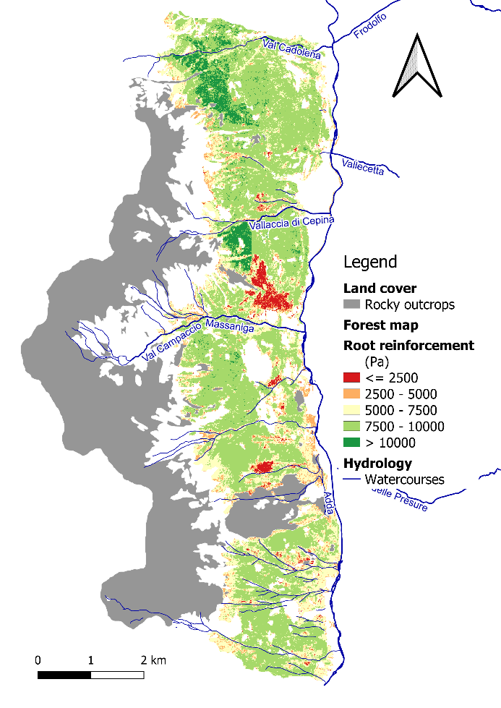
Figure 12. The output of rootFORCE in terms of lateral root reinforcement.
Once obtained the contribution of the forest in reducing the hillslope instabilities, we applied the model PRIMULA considering a hyetograph of 100 years return period (i.e., probability of 1% of occurrence each year). PRIMULA provided shallow landslide susceptible maps in function of different scenarios (). In 2022, the area with a probability of failure higher than 50% is 43.5 ha and increases due to bark beetle attack. In 2025, the prone landslide area ranges from 48.1 to 55.0 ha for mild and severe scenarios. In 2035, the prone landslide area ranges from 50.5 to 59.4 ha for mild and severe scenarios. Conversely, the scenarios that simulate the consequences of restoration activities, predict a significant stabilization reducing the potential unstable area until 30.3 ha in 2025 and 25.9 ha in 2035.

Table 9. PRIMULA simulations in fucntion of different future scenarios.
Year | Disturbance | Scenario | Damaged area/Restored area | Difference in prone-landslide area (m²)
2022 | Bark beetle infestation | Observed | 22 | +434,800
2025 | Bark beetle infestation | Mild | 42 (3 times) | +480,900
2025 | Bark beetle infestation | Moderate | 70 (5 times) | +502,900
2025 | Bark beetle infestation | Severe | 112 (8 times) | +550,200
2035 | Bark beetle infestation | Mild | 84 (6 times) | +505,200
2035 | Bark beetle infestation | Moderate | 143 (10 times) | +559,100
2035 | Bark beetle infestation | Severe | 224 (16 times) | +594,500
2025 | Restoration | Restored | 99 | +303,700
2035 | Restoration | Restored | 110 | +258,900

Additional absorption of CO₂
In the case of the interventions in the municipality of Valdisotto, additional carbon sinks can be generated by the following activities (Table 10):
- Restoration of bark beetle areas: the intervention avoids the future emission into the atmosphere of part of the carbon stored in the dead forest mass in the process of wood decomposition.
- Prevention of bark beetle spread: the intervention avoids the future emission into the atmosphere of part of the carbon stored in the living forest mass, and the decline of carbon sink for a certain number of years resulting from new insect attacks.
- Restoration and reforestation: the intervention shortens the delay in germination and establishment of forest renewal.
Table 10. Areas affected by forest restoration in 2025 and 2035.
Area (ha) | 2025 | 2035 | Total
Restoration of new bark beetle areas | 9.0 | 0.0 | 9.0
Restoration of old bark beetle areas | 4.0 | 4.0 | 8.0
Prevention of new beetle spread in buffer areas | 7.0 | 0.0 | 7.0
Restoration of uprooted forests | 8.0 | 8.0 | 16.0
Reforestation on cleared areas | 39.0 | 39.0 | 78.0

For the quantification of additional carbon sinks, we fixed the assumptions reported in Table 11:
Table 11. Assumptions for quantification of additional carbon sink.
Symbol | Variable | Value
F_{wd} | Wood carbon emitted into the atmosphere after decomposition (%) | 60
S_{wd} | Wood carbon sequestered in the soil after decomposition (%) | 40
I_{bb} | Bark beetle damage intensity (on standing tree volume) (%) | 80
HE | Effectiveness of harvesting damaged forests (%) | 70
HL | Losses from wood harvesting and processing (%) | 10
T_{m-for} | Mature forest age (years) | 120
T_{reg} | Regeneration delay in absence of interventions (years) | 10
d_{z-sink} | Duration of zero carbon sink after bark beetle damage (years) | 20
RS | Total biomass / aboveground biomass ratio for spruce (Vitullo et al., 2007) | 1.29
RHO | Density of spruce wood (t m⁻³) | 0.384
INCR | Annual CO₂ sink in spruce forests (t ha⁻¹ year⁻¹) | 8.85
VOL | Standing volume of mature spruce (m³ ha⁻¹) (Gasparini, 2013) | 380
VOL_{bb} | Forest volume in new bark beetle areas (m³ ha⁻¹) | 350
VOL_{obb} | Forest volume in old bark beetle areas (m³ ha⁻¹) | 250
CD | Carbon density of dry matter (kg kg⁻¹) | 0.5
MM | CO₂ to C mass ratio (kg kg⁻¹) | 3.67

Then, we adopted the following procedure:
${\left(CO_{2}\right)}_{after}={\left(CO_{2}\right)}_{logging}∙F_{wd}$ (Eq.6)
where ${\left(CO_{2}\right)}_{after}$ are the carbon emissions avoided after bark beetle, ${\left(CO_{2}\right)}_{logging}$ is the carbon dioxide captured in logged wood, and $F_{wd}$ is the fraction of carbon emitted into the atmosphere from wood decomposition.
${\left(CO_{2}\right)}_{logging}={\left(CO_{2}\right)}_{for}∙I_{bb}∙HE∙(1-HL)$ (Eq.7)
where ${\left(CO_{2}\right)}_{for}$ is the carbon dioxide stored by the forest, $I_{bb}$ is the damage intensity of bark beetle , $HE$ is the effectiveness of harvesting damaged forests and $HL$ are the harvest losses.
${\left(CO_{2}\right)}_{benefits}={\left(CO_{2}\right)}_{damages}+{\left(CO_{2}\right)}_{losses}$ (Eq.8)
where ${\left(CO_{2}\right)}_{benefits}$ are the carbon emissions avoided from prevention measures, ${\left(CO_{2}\right)}_{damages}$ are the carbon emission caused by damages and ${\left(CO_{2}\right)}_{losses}$ are emission caused by carbon losses.
${\left(CO_{2}\right)}_{damages}={\left(CO_{2}\right)}_{for}∙DI∙F_{wd}$ (Eq.9)
${\left(CO_{2}\right)}_{losses}={\left(CO_{2}\right)}_{annual}∙d_{z-sink}∙F_{wd}$ (Eq.10)
where $d_{z-sink}$ is the duration of zero carbon sink after bark beetle attack.
${\left(CO_{2}\right)}_{ref}={\left(CO_{2}\right)}_{m-for}∙\frac{T_{reg}}{T_{m}-for}$ (Eq.11)
where ${\left(CO_{2}\right)}_{ref}$ is the carbon dioxide sink acceleration from the reforestation, ${\left(CO_{2}\right)}_{m-for}$ is the carbon storage of a mature forest, $T_{reg}$ is the regeneration delay, and $T_{m-for}$ is the mature forest age.
The additional absorption of CO₂, or the emissions avoided, were calculated according to a methodology compatible with the IPCC 2006 guidelines for accounting for greenhouse gas emissions and absorptions in agriculture, forest and other land uses (https://www.ipcc-nggip.iges.or.jp/public/2006gl/vol4.html):
${\left(CO_{2}\right)}_{tot}=VOL x RS x RHO x CD x MM$ (Eq.12)
Where VOL is the standing volume of mature spruce forest, RS is the total to aboveground biomass ratio for spruce forests, RHO is the wood density of spruce, CD is carbon density, and MM is mass ratio between CO₂ and elemental carbon.
The planned interventions are capable of generating an additional CO₂ benefit of to 4637 tons by 2025 and 6168 total tons by 2035 (Table 12). Compliance with the permanence requirement is ensured by the guaranteed duration of the effects of the interventions for a period of more than 30 years.

Table 12. Additional carbon benefits for the interventions at year 2025 and 2035.
Action | tCO₂/ha | tCO₂ in 2025 | tCO₂ in 2035
Restoration of new bark beetle areas | 89.41 | 801.01 | 801.01
Restoration of old bark beetle areas | 63.87 | 271.15 | 542.31
Prevention of new beetle spread in buffer areas | 330.09 | 2304.04 | 2304.04
Restoration of uprooted forests | 26.75 | 213.87 | 427.75
Reforestation on cleared areas | 26.75 | 1046.53 | 2093.06
TOTAL |  | 4636.61 | 6168.17

Stewardship activities

Conclusion and discussion
Once estimated the EBi and detected the areas that request a rehabilitation, we planned several restoration activities and estimated their costs as shown in Table 13.
Table 13. Restoration activities: description, areas and costs. Costs are estimated according to the price list of the local authorities ("Prezzario delle Opere Forestali" - Update 2022 Regione Lombardia - Decreto N° 9068 23/06/2022).
Damage | Priority | Activity | Area (ha) | Cost (€/ha) | Costs (€)
Recent bark beetle attack | I | Rehabilitation | 8.96 | 12,990 | 116,380
Past bark beetle attack | III | Rehabilitation | 8.49 | 9,155 | 77,744
Potential bark beetle attack | II | Preventive measures (buffer areas) | 6.98 | 5,290 | 36,928
Eroded area | I | Soil-bioengineering techniques for erosion control | 1.21 | 307 | 92,094
Area with windthrown trees | II | Removal of dead biomass | 15.99 | 7,691 | 122,976
Cleared area | I-II-III | Reforastation | 78.24 | 5,081 | 397,567
Cleared area | III | Silvicultural actions | 78.24 | 1,216 | 95,165
 |  | Total | 110.91 |  | 938,854

A summary description of the restoration activities follows:
- Recent bark beetle attack: The priority here is protect healthy plants from infestation. Trees that show the first symptoms of attack must be timely removed (before the leaves turn red). Bait trees must be prepared and activated with pheromones in the center of the damaged areas (at least 3 per hectare) for the capture of flying adults, in combination with the use of repellent substances on the marginal trees of the infested area (“push and pull” method). Removed trees must be processed and treated immediately after capture. Carry out selective thinning, favoring all species other than spruce, to the surrounding stand, aimed at strengthening the surviving trees and improving their health, stability and growth. Restoration in areas with poor regeneration includes planting of multi-species groups of trees, including pioneer species, and must be completed, if necessary, with soil protection works for the control of erosion and water runoff and the prevention of hydrogeological instability.

- Past bark beetle attack: The presence of standing dead trees does not in itself increase the risk of spreading the pathogen, which has long since moved away from the affected areas individuals. On the contrary, these areas serve as habitat for natural antagonists of the bark beetle. In compliance with the provisions of the regional guidelines for the protection of forests from the bark beetle (C.R.n ° 56 of 31/5/2022), in areas at risk of soil instability or with insufficient regeneration, dead trees can prove particularly useful. Remove old bark beetles only if they represent a danger to fruition or in the most easily accessible areas; release all surviving seed trees; if the natural regeneration is not observed, carry out localized tree planting with preparatory and / or definitive species depending on the situation, accompanied by protective systems against herbaceous competition and herbivores. Protection can be guaranteed also by arranging dead trees horizontally after having limbed them and anchored to their stumps, which have to be cut at least 150 cm in height. Other dead stems can be used to create trestles for protection from avalanches or piled at 60 ° inclination relative to slope direction to slow down falling rocks, where such danger is present. Particular attention must be paid to the health conditions of the surrounding buffer areas, where timely removal of affected trees (i.e., before the crown turns red) must be carried out, together with selective thinning, aimed at strengthening the surviving trees and improving their health, stability and growth.

- Potential bark beetle attack: In order to counter the progressive spread of the bark beetle in the areas adjacent to the attack sites, it is necessary to adopt preventive actions to defend healthy trees. Particular attention must be paid to verifying the health conditions of the trees surrounding the areas affected by the bark beetle, especially in dense and single-layered stands that represent the areas most vulnerable to new attacks. Preventive interventions consist in carrying out selective thinning, aimed at strengthening the surviving trees and improving their general health, stability and growth. In carrying out the thinning , species other than spruce must be spared as much as possible in order to improve biodiversity. The material deriving from the thinning must in any case be removed from the forest, when not chipped in favorable conditions of accessibility, while a part of it can be used on site as bait logs, then promptly destroyed on site after capture.

- Areas with windthrown trees: where downed trees cannot be removed due to high intervention costs and operational difficulties, the priority is to accelerate the decay of the trees left on the ground, in order to create favorable conditions for the establishment of natural regeneration, to improve the transitability of the sites, and reduce forest fire potential, while at the same time maintaining the protection functions from hydrogeological hazards. Remove downed trees only in the most accessible areas, otherwise proceed with limbing, debarking and splitting of the stems on site. Wood pieces will be piled in small stacks to protect the soil and prevent the downslope movement of large sized material. Branches will be arranged in separate mounds, or chipped and removed where possible. If natural regeneration is absent, on maximum 60% of total areas carry out tree planting in groups using suitable (pioneer in gaps>500 m², mesophilous or tolerant if smaller ) species. Establish protections from ungulate browsing, e.g. shelters or enclosures, and plan for emergency irrigation in case of drought. To facilitate the establishment of pioneer species such as larch,apply a shallow soil disturbance during logging or planting. In areas difficult to access, consider direct seeding. Avoid planting where the gaps are too small to provide good lighting to the new trees. The remaining 40% of areas with windthrown trees will be left to natural regeneration by seeds of surrounding trees.

- Cleared areas: In the presence of gaps <5000 m², created as a result of salvage logging of trees damaged by wind or insects, natural regeneration can establish starting from the gap edge. In forests with a predominant protective function, restoration can be accelerated by localized planting of trees in groups, starting from situations with poor soil fertility or blocked succession, using pioneer species with a variable density depending on the local situations, accompanied by protective systems againt animal browsing and maintenance actions in the following years to guarantee tree survival and establishment. In cleared areas >5000 m², establishment of natural regeneration is slow and difficult due to the steep slope, explosure to drought and poor soil fertility. The aim is therefore to accelerate infilling of large gaps where sufficient natural regeneration has not yet been established, to restore tree cover over large areas and increase tree density in areas with steep slope and/or vulnerable to hydrogeological instability, while also increasing tree diversity. Carry out tree planting with medium to high density (1600-2000 trees per hectare), starting from situations with poor soil fertility or blocked dynamics, using multispecific groups, with both pioneer, drought-tolerant species, and more demanding species, accompanied by protective systems against animal browsing and maintenance actions foreseen in the three years following plantation. Any deadwood still present on site can be used as support point and nurse site for planted trees. Active restoration techniques can aldo include micro-seeding close to the uprooted stumps, using glueing additives and natural fertilizers, using pre-sown mattresses, or recurring to seeding drones in areas with difficult accessibility. It is foreseen to apply active restoration of this kind on 60% of the cleared surfaces, starting from situations in which there is not already a marked tendency towards the process of natural regeneration.

Supplementary materials

Performance indexes
The used performance indexes are summarized in the following Table 14.
Table 14. List of performance indexes
Performance index | Formula
Mean absolute error | $$mae=\frac{1}{n}\sum_{i=1}^{n}{\left|y_{i}-\hat{y_{i}}\right|}$$
Mean squared error | $$mse=\frac{1}{n}\sum_{i=1}^{n}{{\left(y_{i}-\hat{y_{i}}\right)}^{2}}$$
Root mean squared error | $$rmse=\sqrt{\frac{1}{n}\sum_{i=1}^{n}{{\left(y_{i}-\hat{y_{i}}\right)}^{2}}}$$
Mean squared logarithmic error | $$msle=\frac{1}{n}\sum_{i=1}^{n}{{\left[\log\left(1+y_{i}\right)-\log\left(1+\hat{y_{i}}\right)\right]}^{2}}$$
Mean absolute percentage error | $$mape=\frac{1}{n}\sum_{i=1}^{n}{\frac{\left|y_{i}-\hat{y_{i}}\right|}{\overline{y_{i}}}}$$
Maximum absolute error | $$maxe=\max_{i}{(\left|y_{i}-\hat{y_{i}}\right|)}$$
Explained variance score | $$evs=1-\frac{var(y-\hat{y})}{var(y)}$$

SCS-method
Table 15. Antecedent moisture conditions (AMC).
AMC classes | Dormant season | Growing season
I | < 13 mm | < 36 mm
II | 13-28 mm | 36-53 mm
III | > 28 mm | > 53 mm

The AMC influences the value of CN as follows:
$CN_{I}=\frac{CN_{II}}{2.281-0.01281∙CN_{II}}$ (Eq.13)
$CN_{III}=\frac{CN_{II}}{0.427+0.00573∙CN_{II}}$ (Eq.14)
The hydrological soil group was established in function of the sum of two geopedological indexes ($Π_{1}+Π_{2}$) as follows
Table 16. Geopedological index 1 (Π₁).
Soil structure | Loose soil | Moderate dense soil | Dense soil
Soil texture
Coarse | 1 | 2 | 3
Medium | 4 | 5 | 6
Fine | 7 | 8 | 9

Table 17. Geopedological index 2 (Π₂).
Soil depth | <0.25m | 0.25-0.50m | 0.50-1.00m | >1.00m
Soil permeability
High | 6.5 | 4 | 3 | 2
Medium | 7.5 | 6.5 | 5.5 | 5.5
Low | 9 | 8.5 | 7.5 | 7.5

Table 18. Hydrological soil group.
Hydrologic soil group | A | B | C | D
$$Π_{1}+Π_{2}$$ | 0≤$Π$ ≤5 | 6≤ $Π$ ≤10 | 11≤ $Π$ ≤15 | 16≤$Π$ ≤19

Table 19. CN values in function of land cover and hydrological soil group (Mishra and Singh, 2003).
Corine Land Cover: description | A | B | C | D
111 - Continuous urban fabric | 89 | 92 | 94 | 95
112 - Discontinuous urban fabric | 77 | 85 | 90 | 92
121 - Industrial or commercial units | 81 | 88 | 91 | 93
122 - Road and rail networks and associated land | 98 | 98 | 98 | 98
123 - Port areas | 98 | 98 | 98 | 98
124 - Airports | 98 | 98 | 98 | 98
131 - Mineral extraction sites | 76 | 85 | 89 | 91
132 - Dump sites | 81 | 88 | 91 | 93
133 - Construction sites | 77 | 86 | 91 | 94
134 - Aree degradate non utilizzate e non vegetate | 72 | 82 | 87 | 90
141 - Green urban spaces | 49 | 69 | 79 | 84
142 - Sport and leisure facilities | 68 | 79 | 86 | 89
211 - Not-irrigated arable land | 61 | 73 | 81 | 84
212 - Permanently irrigated land | 62 | 71 | 78 | 81
213 - Rice fields | 62 | 71 | 78 | 81
221 - Vineyards | 76 | 85 | 90 | 93
222 - Fruit trees and berry plantations | 43 | 65 | 76 | 82
223 - Olive groves | 43 | 65 | 76 | 82
224 – Wood arboriculture plantations | 67 | 78 | 85 | 89
231 - Pastures | 49 | 69 | 79 | 84
241 - Annual crops associated with permanent crops | 61 | 73 | 81 | 84
242 - Complex cultivation patterns | 61 | 73 | 81 | 84
243 - Land principally occupied by agriculture with significant areas of natural vegetation | 61 | 73 | 81 | 84
244 - Agro-forestry areas | 67 | 78 | 85 | 89
311 - Broad-leaved forest | 36 | 60 | 73 | 79
312 - Coniferous forest | 36 | 60 | 73 | 79
313 - Mixed forests | 36 | 60 | 73 | 79
314 - Reforestation | 35 | 56 | 70 | 77
321 - Natural grassland | 49 | 69 | 79 | 84
322 - Moors and heathland | 49 | 69 | 79 | 84
323 - Sclerophyllous vegetation | 35 | 56 | 70 | 77
324 - Transitional woodland-shrub | 35 | 56 | 70 | 77
331 - Beaches dunes sands | 46 | 65 | 77 | 82
332 - Bare rocks | 96 | 96 | 96 | 96
333 - Sparsely vegetated areas | 63 | 77 | 85 | 88
334 - Burnt areas | 81 | 88 | 91 | 93
335 - Glaciers and perpetual snow | 36 | 60 | 73 | 79
411 - Inland marshes | 98 | 98 | 98 | 98
412 - Peat bogs | 98 | 98 | 98 | 98
421 - Salt marshes | 98 | 98 | 98 | 98
422 - Salines | 98 | 98 | 98 | 98
423 - Intertidal flats | 98 | 98 | 98 | 98
511 - Water courses | 98 | 98 | 98 | 98
512 - Water bodies | 98 | 98 | 98 | 98
521 - Coastal lagoons | 98 | 98 | 98 | 98
522 - Estuaries | 98 | 98 | 98 | 98

References
Baier, P., Pennerstorfer, J., Schopf, A., 2007. PHENIPS—A comprehensive phenology model of Ips typographus (L.) (Col., Scolytinae) as a tool for hazard rating of bark beetle infestation. Forest Ecology and Management 249, 171–186. https://doi.org/10.1016/j.foreco.2007.05.020
Bakke, A., 1989. The recent Ips typographus outbreak in Norway - experiences from a control program. Ecography 12, 515–519. https://doi.org/10.1111/j.1600-0587.1989.tb00930.x
Bakke, A., 1983. Host tree and bark beetle interaction during a mass outbreak of Ips typographus in Norway. Zeitschrift für Angewandte Entomologie 96, 118–125. https://doi.org/10.1111/j.1439-0418.1983.tb03651.x
Beck, H.E., Zimmermann, N.E., McVicar, T.R., Vergopolan, N., Berg, A., Wood, E.F., 2018. Present and future Köppen-Geiger climate classification maps at 1-km resolution. Sci Data 5, 180214. https://doi.org/10.1038/sdata.2018.214
Biedermann, P.H.W., Müller, J., Grégoire, J.-C., Gruppe, A., Hagge, J., Hammerbacher, A., Hofstetter, R.W., Kandasamy, D., Kolarik, M., Kostovcik, M., Krokene, P., Sallé, A., Six, D.L., Turrini, T., Vanderpool, D., Wingfield, M.J., Bässler, C., 2019. Bark beetle population dynamics in the Anthropocene: challenges and solutions. Trends in Ecology & Evolution 34, 914–924. https://doi.org/10.1016/j.tree.2019.06.002
Blackman, M.W., 1924. The effect of deficiency and excess in rainfall upon the Hickory bark beetle (Eccoptogaster quadrispinosus Say). Journal of Economic Entomology 17, 460–470. https://doi.org/10.1093/jee/17.4.460
Breiman, L., 2001. Random forests. Machine Learning 45, 5–32.
Brovelli, M.A., Crespi, M., Fratarcangeli, F., Giannone, F., Realini, E., 2008. Accuracy assessment of high resolution satellite imagery orientation by leave-one-out method. ISPRS Journal of Photogrammetry and Remote Sensing 63, 427–440. https://doi.org/10.1016/j.isprsjprs.2008.01.006
Chapman, T.B., Veblen, T.T., Schoennagel, T., 2012. Spatiotemporal patterns of mountain pine beetle activity in the southern Rocky Mountains. Ecology 93, 2175–2185. https://doi.org/10.1890/11-1055.1
Cislaghi, A., Alterio, E., Fogliata, P., Rizzi, A., Lingua, E., Vacchiano, G., Bischetti, G.B., Sitzia, T., 2021. Effects of tree spacing and thinning on root reinforcement in mountain forests of the European Southern Alps. Forest Ecology and Management 482, 118873. https://doi.org/10.1016/j.foreco.2020.118873
Cislaghi, A., Chiaradia, E.A., Bischetti, G.B., 2017. Including root reinforcement variability in a probabilistic 3D stability model. Earth Surface Processes and Landforms 42, 1789–1806. https://doi.org/10.1002/esp.4127
Colombari, F., Schroeder, M.L., Battisti, A., Faccoli, M., 2013. Spatio-temporal dynamics of an Ips acuminatus outbreak and implications for management. Agricultural and Forest Entomology 15, 34–42. https://doi.org/10.1111/j.1461-9563.2012.00589.x
Craighead, F.C., 1925. Bark-beetle epidemics and rainfall deficiency. Journal of Economic Entomology 18, 577–586. https://doi.org/10.1093/jee/18.4.577
Crosta, G.B., Chen, H., Lee, C.F., 2004. Replay of the 1987 Val Pola landslide, Italian Alps. Geomorphology 60, 127–146. https://doi.org/10.1016/j.geomorph.2003.07.015
Crosta, G.B., Frattini, P., 2006. Formation, characterization and modelling of the 1987 Val Pola rock-avalanche dam (Italy). Italian Journal of Engineering Geology and Environment Special Issue I, 145–150. https://doi.org/10.4408/IJEGE.2006-01.S-20
Faccoli, M., 2009. Effect of weather on Ips typographus (Coleoptera Curculionidae) phenology, voltinism, and associated spruce mortality in the Southeastern Alps. Environ Entomol 38, 307–316. https://doi.org/10.1603/022.038.0202
Faccoli, M., 2002. Winter mortality in sub-corticolous populations of Ips typographus (Coleoptera, Scolytidae) and its parasitoids in the south-eastern Alps. Anzeiger für Schädlingskunde | Journal of Pest Science 75, 62–68. https://doi.org/10.1034/j.1399-5448.2002.02017.x
Forster, B., Meier, F., Gall, R., 2003. Bark beetle management after a mass attack: some Swiss experiences, in: Proceedings of Ecology, Survey and Management of Forest Insects. pp. 10–15.
Gasparini, P., 2013. Il contenuto di carbonio delle foreste italiane: inventario nazionale delle foreste e dei serbatoi forestali di carbonio INFC2005 : metodi e risultati dell’indagine integrativa. [Roma] : Ministero delle politiche agricole alimentari e forestali. Corpo forestale dello Stato, [Roma], CRA Consiglio per la Ricerca e la sperimentazione in Agricoltura.
Georgiev, G., Georgieva, M., Dimitrov, S., Iliev, M., Trenkin, V., Mirchev, P., Belilov, S., 2022. Remote sensing assessment of the expansion of Ips typographus attacks in the Chuprene reserve, Western Balkan range. Forests 13, 39. https://doi.org/10.3390/f13010039
Georgieva, M., Belilov, S., Dimitrov, S., Iliev, M., Trenkin, V., Mirchev, P., Georgiev, G., 2022. Application of remote sensing data for assessment of bark beetle attacks in pine plantations in Kirkovo region, the Eastern Rhodopes. Forests 13, 620. https://doi.org/10.3390/f13040620
Gislason, P.O., Benediktsson, J.A., Sveinsson, J.R., 2006. Random Forests for land cover classification. Pattern Recognition Letters 27, 294–300. https://doi.org/10.1016/j.patrec.2005.08.011
Grégoire, J.-C., Raffa, K.F., Lindgren, B.S., 2015. Economics and politics of bark beetles, in: Bark Beetles. Elsevier, pp. 585–613. https://doi.org/10.1016/B978-0-12-417156-5.00015-0
Havašová, M., Ferenčík, J., Jakuš, R., 2017. Interactions between windthrow, bark beetles and forest management in the Tatra national parks. Forest Ecology and Management 391, 349–361. https://doi.org/10.1016/j.foreco.2017.01.009
Hlásny, T., Krokene, P., Liebhold, A., Montagné-Huck, C., Müller, J., Qin, H., Raffa, K., Schelhaas, M.-J., Seidl, R., Svoboda, M., Viiri, H., European Forest Institute, 2019. Living with bark beetles: impacts, outlook and management options (From Science to Policy), From Science to Policy. European Forest Institute. https://doi.org/10.36333/fs08
Huete, A., Didan, K., Miura, T., Rodriguez, E.P., Gao, X., Ferreira, L.G., 2002. Overview of the radiometric and biophysical performance of the MODIS vegetation indices. Remote Sensing of Environment 83, 195–213. https://doi.org/10.1016/S0034-4257(02)00096-2
Ingram, J.C., Dawson, T.P., Whittaker, R.J., 2005. Mapping tropical forest structure in southeastern Madagascar using remote sensing and artificial neural networks. Remote Sensing of Environment 94, 491–507. https://doi.org/10.1016/j.rse.2004.12.001
Kausrud, K.L., Grégoire, J.-C., Skarpaas, O., Erbilgin, N., Gilbert, M., Økland, B., Stenseth, N.Chr., 2011. Tree wanted - dead or alive! Host selection and population dynamics in tree-killing bark beetles. PLoS ONE 6, e18274. https://doi.org/10.1371/journal.pone.0018274
Kautz, M., Dworschak, K., Gruppe, A., Schopf, R., 2011. Quantifying spatio-temporal dispersion of bark beetle infestations in epidemic and non-epidemic conditions. Forest Ecology and Management 262, 598–608. https://doi.org/10.1016/j.foreco.2011.04.023
Kautz, M., Peter, F.J., Harms, L., Kammen, S., Delb, H., 2022. Patterns, drivers and detectability of infestation symptoms following attacks by the European spruce bark beetle. J Pest Sci. https://doi.org/10.1007/s10340-022-01490-8
Kohavi, R., 1995. A study of cross-validation and bootstrap for accuracy estimation and model selection, in: Appears in the International Joint Conference on Artificial Intelligence (IJCAI).
Koreň, M., Jakuš, R., Zápotocký, M., Barka, I., Holuša, J., Ďuračiová, R., Blaženec, M., 2021. Assessment of machine learning algorithms for modeling the spatial distribution of bark beetle infestation. Forests 12, 395. https://doi.org/10.3390/f12040395
Kunca, A., Zúbrik, M., Galko, J., Vakula, J., Leontovyč, R., Konôpka, B., Nikolov, C., Gubka, A., Longauerová, V., Maľová, M., Rell, S., Lalík, M., 2019. Salvage felling in the Slovak Republic’s forests during the last twenty years (1998–2017). Central European Forestry Journal 65, 3–11. https://doi.org/10.2478/forj-2019-0007
Liaw, A., Wiener, M., 2022. Package “randomForest.”
Lu, D., Chen, Q., Wang, G., Liu, L., Li, G., Moran, E., 2016. A survey of remote sensing-based aboveground biomass estimation methods in forest ecosystems. International Journal of Digital Earth 9, 63–105. https://doi.org/10.1080/17538947.2014.990526
Maindonald, J., Braun, W.J., 2003. Data analysis and graphics using R: an example-based approach, Third Edition. ed, Cambridge Series in Statistical and Probabilistic Mathematics. CAMBRIDGE UNIVERSITY PRESS, Cambridge, United Kingdom.
Marini, L., Ayres, M.P., Battisti, A., Faccoli, M., 2012. Climate affects severity and altitudinal distribution of outbreaks in an eruptive bark beetle. Climatic Change 115, 327–341. https://doi.org/10.1007/s10584-012-0463-z
Marini, L., Økland, B., Jönsson, A.M., Bentz, B., Carroll, A., Forster, B., Grégoire, J.-C., Hurling, R., Nageleisen, L.M., Netherer, S., Ravn, H.P., Weed, A., Schroeder, M., 2017. Climate drivers of bark beetle outbreak dynamics in Norway spruce forests. Ecography 40, 1426–1435. https://doi.org/10.1111/ecog.02769
Mezei, P., 2017. Storms, temperature maxima and the Eurasian spruce bark beetle Ips typographus: an infernal trio in Norway spruce forests of the Central European High Tatra Mountains. Agricultural and Forest Meteorology 242, 85–95. http://dx.doi.org/10.1016/j.agrformet.2017.04.004
Migas-Mazur, R., Kycko, M., Zwijacz-Kozica, T., Zagajewski, B., 2021. Assessment of Sentinel-2 images, support vector machines and change detection algorithms for bark beetle outbreaks mapping in the Tatra Mountains. Remote Sensing 13, 3314. https://doi.org/10.3390/rs13163314
Mishra, S.K., Singh, V.P., 2003. Soil Conservation Service Curve Number (SCS-CN) Methodology, Water Science and Technology Library. Springer Netherlands, Dordrecht. https://doi.org/10.1007/978-94-017-0147-1
Müller, J., Bußler, H., Goßner, M., Rettelbach, T., Duelli, P., 2008. The European spruce bark beetle Ips typographus in a national park: from pest to keystone species. Biodivers Conserv 17, 2979–3001. https://doi.org/10.1007/s10531-008-9409-1
Nardi, D., Finozzi, V., Battisti, A., 2022. Massive windfalls boost an ongoing spruce bark beetle outbreak in the Southern Alps. IFM 77, 23–34. https://doi.org/10.36253/ifm-1617
Pal, M., 2005. Random forest classifier for remote sensing classification. International Journal of Remote Sensing 26, 217–222. https://doi.org/10.1080/01431160412331269698
Potterf, M., Bone, C., 2017. Simulating bark beetle population dynamics in response to windthrow events. Ecological Complexity 32, 21–30. https://doi.org/10.1016/j.ecocom.2017.08.003
Prasad, A.M., Iverson, L.R., Liaw, A., 2006. Newer classification and regression tree techniques: bagging and random forests for ecological prediction. Ecosystems 9, 181–199. https://doi.org/10.1007/s10021-005-0054-1
Ravn, H.P., 1985. Expansion of the populations of Ips typographus (L.) (Coleoptera, Scolytidae) and their local dispersal following gale disaster in Denmark. Zeitschrift für Angewandte Entomologie 99, 33–39.
Seidl, R., Rammer, W., Spies, T.A., 2014. Disturbance legacies increase the resilience of forest ecosystem structure, composition, and functioning. Ecological Applications 24, 2063–2077. https://doi.org/10.1890/14-0255.1
Stadelmann, G., Bugmann, H., Wermelinger, B., Bigler, C., 2014. Spatial interactions between storm damage and subsequent infestations by the European spruce bark beetle. Forest Ecology and Management 318, 167–174. https://doi.org/10.1016/j.foreco.2014.01.022
Stadelmann, G., Bugmann, H., Wermelinger, B., Meier, F., Bigler, C., 2013. A predictive framework to assess spatio-temporal variability of infestations by the European spruce bark beetle. Ecography 36, 1208–1217. https://doi.org/10.1111/j.1600-0587.2013.00177.x
Tabacchi, G., Di Cosmo, L., Gasparini, P., Morelli, S., 2011. Stima del volume e della fitomassa delle principali specie forestali italiane. Equazioni di previsione, tavole del volume e tavole della fitomassa arborea epigea. Consiglio per la Ricerca e la sperimentazione in Agricoltura, Unità di Ricerca per il Monitoraggio e la Pianificazione Forestale. Trento. 412 pp. Trento: Consiglio per la Ricerca e la sperimentazione in Agricoltura, Unita di Ricerca per il Monitoraggio e la Pianificazione Forestale (in Italian).
United States Department of Agriculture (USDA), 1972. Part 630 Hydrology - National Engineering Handbook. National Resources Conservation Service, Washington D.C. U.S.A.
USDA National Resources Conservation Service, 1986. Urban hydrology for small watersheds TR55 (No. Technical Release 55). U.S. Department of Agriculture.
Vacchiano, G., Berretti, R., Motta, R., Mondino Borgogno, E., 2018. Assessing the availability of forest biomass for bioenergy by publicly available satellite imagery. iForest 11, 459–468. https://doi.org/10.3832/ifor2655-011
Vitullo, M., De Lauretis, R., Federici, S., 2007. La contabilità del carbonio contenuto nelle foreste italiane. Silvae III, 91–104.
Wermelinger, B., 2004. Ecology and management of the spruce bark beetle Ips typographus—a review of recent research. Forest Ecology and Management 202, 67–82. https://doi.org/10.1016/j.foreco.2004.07.018
Wermelinger, B., Seifert, M., 1999. Temperature‐dependent reproduction of the spruce bark beetle Ips typographus, and analysis of the potential population growth. Ecological Entomology 24, 103–110. https://doi.org/10.1046/j.1365-2311.1999.00175.x
Wulder, M.A., White, J.C., Bentz, B., Alvarez, M.F., Coops, N.C., 2006. Estimating the probability of mountain pine beetle red-attack damage. Remote Sensing of Environment 101, 150–166. https://doi.org/10.1016/j.rse.2005.12.010

Reig, P., and S. Vionnet. 2021. “Volumetric Water Benefit Accounting (VWBA): A Practical Guide to Implementing Water Replenishment Targets.” Working Paper. Bluerisk, Valuing Nature, and CEO Water Mandate. Available at: https://ceowatermandate.org/replenishment-guide.
Reig, P., W. Larson, S. Vionnet, and J.B. Bayart. 2019. “Volumetric Water Benefit Accounting (VWBA): A Method for Implementing and Valuing Water Stewardship Activities.” Working Paper. Washington, DC: World Resources Institute. Available online at www.wri.org/publication/volumetricwater-benefit-accounting.
Motta, R.; Ascoli, D.; Corona, P.; Marchetti, M.; Vacchiano, G. Silviculture and wind damages. The storm “Vaia”. Forest@ Riv. Selvic. Ecol. For. 2018, 15, 94–98.

